Flooded Lands Inventory Estimate: 1990 - 2023

J. Beaulieu

2024-10-07

Table of Contents

# 

## 

### 

#### 

#### 

#### 

#### 

### 

### 

### 

### 

### 

#### 

##### 

##### 

#### 

##### 

##### 

## 

### 

### 

#### 

##### 

##### 

##### 

## 

# 

# Flooded Land Remaining Flooded Land

Flooded lands are defined as water bodies where human activities have 1) caused changes in the amount of surface area covered by water, typically through water level regulation (e.g., constructing a dam), 2) waterbodies where human activities have changed the hydrology of existing natural waterbodies thereby altering water residence times and/or sedimentation rates, in turn causing changes to the natural emission of greenhouse gases, and 3) waterbodies that have been created by excavation, such as canals, ditches and ponds (IPCC 2019). Flooded lands include waterbodies with seasonally variable degrees of inundation, but these waterbodies would be expected to retain some inundated area throughout the year under normal conditions.

Flooded lands are broadly classified as “reservoirs” or “other constructed waterbodies” (IPCC 2019). Other constructed waterbodies include canals/ditches and ponds (flooded land <8 ha surface area). Reservoirs are defined as flooded land greater than 8 ha. IPCC guidance (IPCC 2019) provides default emission factors for reservoirs, ponds, and canals/ditches.

Land that has been flooded for greater than 20 years is defined as flooded land remaining flooded land and land flooded for 20 years or less is defined as land converted to flooded land. The distinction is based on literature reports that CH4 and CO2 emissions are high immediately following flooding, but decline to a steady background level approximately 20 years after flooding (Abril et al. 2005; Barros et al. 2011; Teodoru et al. 2012). Emissions of CH4 are estimated for flooded land remaining flooded land, but CO2 emissions are not included as they are 6-126 Inventory of U.S. Greenhouse Gas Emissions and Sinks: 1990–2022 primarily the result of decomposition of organic matter entering the waterbody from the catchment or contained in inundated soils and are captured in Chapter 6, Land Use, Land-Use Change, and Forestry.

Nitrous oxide emissions from flooded lands are largely related to input of organic or inorganic nitrogen from the watershed. These inputs from runoff/leaching/deposition are largely driven by anthropogenic activities such as land-use change, wastewater disposal or fertilizer application in the watershed or application of fertilizer or feed in aquaculture. These emissions are not included here to avoid double-counting of N2O emissions which are captured in other source categories, such as indirect N2O emissions from managed soils (Section 5.4, Agricultural Soil Management) and wastewater management (Section 7.2, Wastewater Treatment and Discharge).

## Emissions from Flooded Land Remaining Flooded Land-Reservoirs

Reservoirs are designed to store water for a wide range of purposes including hydropower, flood control, drinking water, and irrigation. In 2022, the United States and Puerto Rico hosted 113.0476597 million hectares of reservoirs in the flooded land remaining flooded land category. These reservoirs are distributed across all 6 of the aggregated climate zones used to define flooded land emission factors (Figure 6-10)(IPCC 2019).

### 

**Figure 6-10: U.S. Reservoirs (black polygons) in the Flooded Land Remaining Flooded Land Category in 2022**

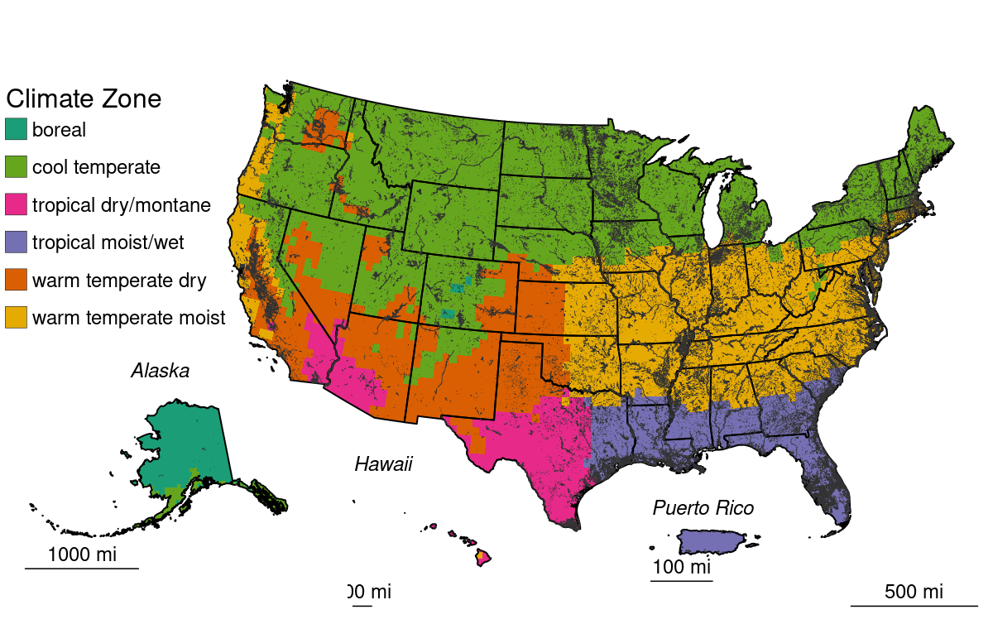

Methane is produced in reservoirs through the microbial breakdown of organic matter. Per unit area, CH4 emission rates tend to scale positively with temperature and system productivity (i.e., abundance of algae), but negatively with system size (i.e., depth, surface area). Methane produced in reservoirs can be emitted from the reservoir surface or exported from the reservoir when CH4-rich water passes through the dam. This exported CH4 can be released to the atmosphere as the water passes through hydropower turbines or the downstream river channel. Methane emitted to the atmosphere via this pathway is referred to as “downstream emissions.”

Table 6-80 and Table 6-81 below summarize nationally aggregated CH4 emissions from reservoirs. The increase in CH4 emissions through the time series is attributable to reservoirs matriculating from the land converted to flooded land category into the flooded land remaining flooded land category.

### 

Total CH4 emissions from reservoirs in FLRFL are shown in the text in both kt CH4 and MMT CH4-CO2-eq. These tables are knit into the document below, but are also calculated in the “tables” tab of the Excel spreadsheet. Double check against Excel to confirm calculations.

Table 1: Table 6-80: CH4 Emissions from Flooded Land Remaining Flooded Land—Reservoirs (MMT CO2 Eq.)

| Source | 1990 | 2005 | 2019 | 2020 | 2021 | 2022 | 2023 |
| --- | --- | --- | --- | --- | --- | --- | --- |
| **Reservoirs** |  |  |  |  |  |  |  |
| surface | 432 | 434 | 434 | 434 | 434 | 434 | 434 |
| downstream | 39 | 39 | 39 | 39 | 39 | 39 | 39 |
| **Total** | **471** | **473** | **473** | **473** | **473** | **473** | **473** |
| Note: Totals may not sum to due independent rounding. | | | | | | | |

Table 2: Table 6-81: CH4 Emissions from Flooded Land Remaining Flooded Land—Reservoirs (kt CH4)

| Source | 1990 | 2005 | 2019 | 2020 | 2021 | 2022 | 2023 |
| --- | --- | --- | --- | --- | --- | --- | --- |
| **Reservoirs** |  |  |  |  |  |  |  |
| surface | 15438 | 15494 | 15504 | 15504 | 15504 | 15505 | 15505 |
| downstream | 1389 | 1394 | 1395 | 1395 | 1395 | 1395 | 1395 |
| **Total** | **16827** | **16888** | **16899** | **16899** | **16899** | **16900** | **16900** |
| Note: Totals may not sum to due independent rounding. | | | | | | | |

Methane emissions from reservoirs in Texas, Florida, and Louisiana (Figure 6-11, Table 6-82) compose 34 percent of national CH4 emissions from reservoirs in 2022. Emissions from these states are particularly high due to 1) the large expanse of reservoirs in these states (Table 6-85) and 2) the high CH4 emission factor for the tropical dry/montane and topical moist climate zones which encompass a majority of the flooded land area in these states (Figure 6-10, Table 6-83).

Methane emissions from reservoirs in flooded land remaining flooded land increased 6.4 percent from 1990 to 2022 due to the matriculation of reservoirs in land converted to flooded land to flooded land remaining flooded land.

### 

**Figure 6-11: Total CH4 Emissions (Downstream + Surface) from Reservoirs in Flooded Land Remaining Flooded Land in 2023 (kt CH4)**

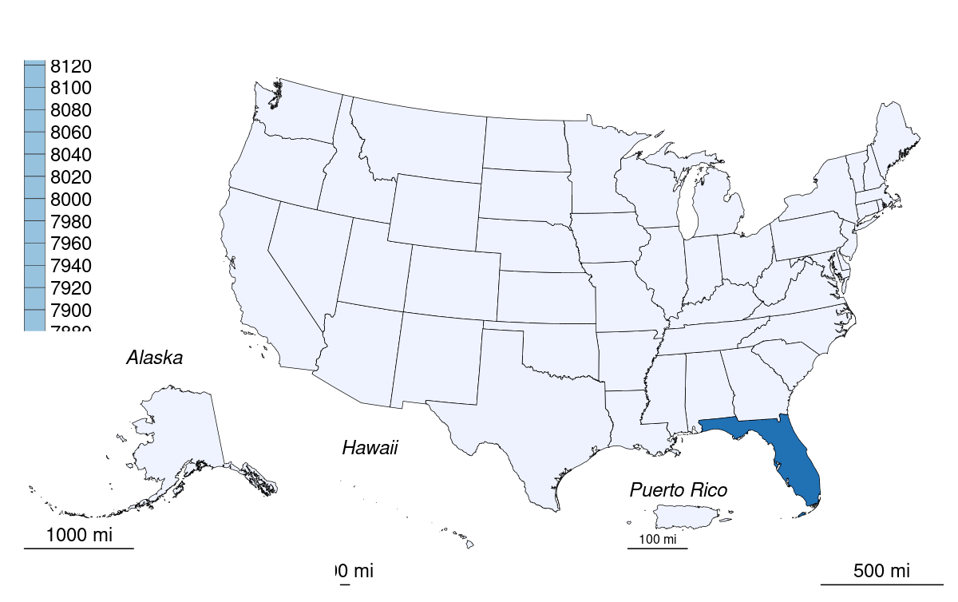

### 

Table 3: Table 6-82: Surface and Downstream CH4 Emissions from Reservoirs in Flooded Land Remaining Flooded Land in 2023 (kt CH4)

| State | Surface | Downstream | Total |
| --- | --- | --- | --- |
| Alabama | 22 | 2 | 24 |
| Alaska | 1 | + | 1 |
| Arizona | 14 | 1 | 16 |
| Arkansas | 25 | 2 | 28 |
| California | 42 | 4 | 46 |
| Colorado | 7 | 1 | 7 |
| Connecticut | 3 | + | 3 |
| Delaware | 4 | + | 4 |
| District of Columbia | 1 | + | 1 |
| Florida | 14653 | 1319 | 15971 |
| Georgia | 34 | 3 | 37 |
| Hawaii | 1 | + | 1 |
| Idaho | 12 | 1 | 13 |
| Illinois | 17 | 2 | 18 |
| Indiana | 6 | 1 | 6 |
| Iowa | 7 | 1 | 7 |
| Kansas | 10 | 1 | 11 |
| Kentucky | 14 | 1 | 15 |
| Louisiana | 60 | 5 | 65 |
| Maine | 15 | 1 | 16 |
| Maryland | 12 | 1 | 13 |
| Massachusetts | 5 | + | 5 |
| Michigan | 10 | 1 | 10 |
| Minnesota | 21 | 2 | 23 |
| Mississippi | 20 | 2 | 22 |
| Missouri | 17 | 2 | 18 |
| Montana | 16 | 1 | 17 |
| Nebraska | 7 | 1 | 7 |
| Nevada | 17 | 2 | 18 |
| New Hampshire | 3 | + | 4 |
| New Jersey | 10 | 1 | 10 |
| New Mexico | 7 | 1 | 7 |
| New York | 17 | 2 | 18 |
| North Carolina | 33 | 3 | 36 |
| North Dakota | 14 | 1 | 15 |
| Ohio | 7 | 1 | 7 |
| Oklahoma | 23 | 2 | 25 |
| Oregon | 15 | 1 | 17 |
| Pennsylvania | 7 | 1 | 8 |
| Puerto Rico | + | + | + |
| Rhode Island | 1 | + | 1 |
| South Carolina | 37 | 3 | 40 |
| South Dakota | 12 | 1 | 13 |
| Tennessee | 19 | 2 | 21 |
| Texas | 137 | 12 | 149 |
| Utah | 21 | 2 | 23 |
| Vermont | 5 | + | 5 |
| Virginia | 24 | 2 | 26 |
| Washington | 22 | 2 | 24 |
| West Virginia | 3 | + | 4 |
| Wisconsin | 11 | 1 | 12 |
| Wyoming | 7 | 1 | 8 |
| + Indicates values less than 0.5 kt. | | | |

### Methodology and Time-Series Consistency

Estimates of CH4 emission for reservoirs in flooded land remaining flooded land follow the Tier 1 methodology in the 2019 Refinement to the 2006 IPCC Guidelines (IPCC 2019). Methane emissions from the surface of these flooded lands are calculated as the product of flooded land surface area and a climate-specific emission factor (Table 6-83). Downstream emissions are calculated as nine percent of the surface emission (Tier 1 default). Total CH4 emissions from reservoirs are calculated as the sum of surface and downstream emissions. National emissions are calculated as the sum of state emissions.

The IPCC default surface emission factors used in the Tier 1 methodology are derived from model-predicted (G-res model, Prairie et al. 2017) emission rates for all reservoirs in the Global Reservoir and Dam (GRanD) database (Lehner et al. 2011). Predicted emission rates were aggregated by the 11 IPCC climate zones (IPCC 2019, Table 7A.2) which were collapsed into six climate zones using a regression tree approach. All six aggregated climate zones are present in the United States.

#### 

Table 4: Table 6-83: IPCC (2019) Default CH4 Emission Factors for Surface Emission from Reservoirs in Flooded Land Remaining Flooded Land

| Climate | Surface emission factor (Mt CH<w:r><w:rPr><w:vertAlign w:val="subscript"></w:vertAlign></w:rPr><w:t xml:space="default">4</w:t></w:r> ha<w:r><w:rPr><w:vertAlign w:val="superscript"></w:vertAlign></w:rPr><w:t xml:space="default">-1</w:t></w:r> y<w:r><w:rPr><w:vertAlign w:val="superscript"></w:vertAlign></w:rPr><w:t xml:space="default">-1</w:t></w:r>) |
| --- | --- |
| Boreal | 0.0136 |
| Cool Temperate | 0.0540 |
| Warm Temperate Dry | 0.1509 |
| Warm Temperate Moist | 0.0803 |
| Tropical Dry/Montane | 0.2837 |
| Tropical Moist/Wet | 0.1411 |
| Note: downstream CH<sub>4</sub> emissions are calculated as 9 percent of surface emissions. Downstream emissions are not calculated for CO<sub>2</sub>. | |

##### Area estimates

U.S. reservoirs were identified from the NHDWaterbody layer in the National Hydrography Dataset Plus V2 (NHD),[1] the National Inventory of Dams (NID),[2] the National Wetlands Inventory (NWI),[3] the Navigable Waterways (NW) network,[4] and the EPA’s Safe Drinking Water Information System (SDWIS).[5] The NHD only covers the conterminous U.S., whereas the NID, NW and NWI also include Alaska, Hawaii, and Puerto Rico.

Waterbodies in the NHDWaterbody layer that were greater than or equal to 8 ha in surface area, not identified as canal/ditch in NHD, and met any of the following criteria were considered reservoirs: 1) the waterbody was classified as “Reservoir” in the NHDWaterbody layer, 2) the waterbody name in the NHDWaterbody layer included “Reservoir”, 3) the waterbody in the NHDWaterbody layer was located in close proximity (up to 100 m) to a dam in the NID, 4) the NHDWaterbody GNIS name was similar to a nearby NID feature (between 100 m to 1000 m), 5) the waterbody intersected a public drinking water intake.

EPA assumes that all features included in the NW network are subject to water-level management to maintain minimum water depths required for navigation and are therefore managed flooded lands. Navigable Waterway features greater than 8 ha in surface area are defined as reservoirs.

NWI features were considered “managed” if they had a Special Modifier value indicating the presence of management activities (Figure 6-12). To be included in the flooded lands inventory, the managed flooded land had to be wet or saturated for at least one season per year (see “Water Regime” in Figure 6-12). NWI features that met these criteria, were greater than 8 ha in surface area, and were not a canal/ditch (see emissions from land converted to flooded land – other constructed waterbodies) were defined as reservoirs.

Any NWI or NHD feature that intersected a drinking water intake point frthroom SDWIS was assumed to be “managed.” The rational being that a waterbody used as a source for public drinking water is typically managed in some capacity - by flow and/or volume control.

Surface areas for identified flooded lands were taken from the NHD, NWI or NW. If features from the NHD, NWI, or NW datasets overlapped, duplicated areas were erased. The first step was to take the final NWI flooded lands features and use it to identify overlapping NHD features. If the NHD feature had its center in a NWI feature, it was removed from analysis. Next, remaining NHD features were erased from any remaining overlapping NWI features. Final selections of NHD and NWI features were used to erase any overlapping NW waterbodies.

Reservoir age was determined by assuming the waterbody was created the same year as a nearby (up to 100 m) NID feature. If no nearby NID feature was identified, it was assumed the waterbody was greater than 20-years old throughout the time series.

IPCC (2019) allows for the exclusion of managed waterbodies from the inventory if the water surface area or residence time was not substantially changed by the construction of the dam. The guidance does not quantify what constitutes a “substantial” change, but here EPA excludes the U.S. Great Lakes from the inventory based on expert judgment that neither the surface area nor water residence time was substantially altered by their associated dams.

Reservoirs were disaggregated by state (using boundaries from the 2016 U.S. Census Bureau[6]) and climate zone. Downstream and surface emissions for cross-state reservoirs were allocated to states based on the surface area that the reservoir occupied in each state. Only the U.S. portion of reservoirs that cross country borders were included in the inventory.

The surface area of reservoirs in flooded land remaining flooded land increased by approximately 0.6 percent from 1990 to 2022 (Table 6-84) due to reservoirs matriculating into flooded land remaining flooded land when they reached 20 years of age.

###### 

Table 5: Table 6-84: National Totals of Reservoir Surface Area in Flooded Land Remaining Flooded Land (millions of ha)

| Surface Area (millions of ha) | 1990 | 2005 | 2019 | 2020 | 2021 | 2022 | 2023 |
| --- | --- | --- | --- | --- | --- | --- | --- |
| reservoir | 112.3 | 112.9 | 113.0 | 113.0 | 113.0 | 113.0 | 113.0 |

###### 

Table 6: Table 6-85: State Breakdown of Reservoir Surface Area in Flooded Land Remaining Flooded Land (millions of ha)

| State | 1990 | 2005 | 2019 | 2020 | 2021 | 2022 | 2023 |
| --- | --- | --- | --- | --- | --- | --- | --- |
| Alabama | 0.22 | 0.22 | 0.22 | 0.22 | 0.22 | 0.22 | 0.22 |
| Alaska | 0.02 | 0.02 | 0.02 | 0.02 | 0.02 | 0.02 | 0.02 |
| Arizona | 0.06 | 0.06 | 0.06 | 0.06 | 0.06 | 0.06 | 0.06 |
| Arkansas | 0.26 | 0.29 | 0.29 | 0.29 | 0.29 | 0.29 | 0.29 |
| California | 0.37 | 0.39 | 0.39 | 0.39 | 0.39 | 0.39 | 0.39 |
| Colorado | 0.08 | 0.09 | 0.09 | 0.09 | 0.09 | 0.09 | 0.09 |
| Connecticut | 0.04 | 0.04 | 0.04 | 0.04 | 0.04 | 0.04 | 0.04 |
| Delaware | 0.05 | 0.05 | 0.05 | 0.05 | 0.05 | 0.05 | 0.05 |
| District of Columbia | 0.01 | 0.01 | 0.01 | 0.01 | 0.01 | 0.01 | 0.01 |
| Florida | 103.83 | 103.84 | 103.84 | 103.85 | 103.85 | 103.85 | 103.85 |
| Georgia | 0.27 | 0.29 | 0.29 | 0.29 | 0.29 | 0.29 | 0.29 |
| Hawaii | + | + | + | + | + | + | + |
| Idaho | 0.17 | 0.19 | 0.19 | 0.19 | 0.19 | 0.19 | 0.19 |
| Illinois | 0.17 | 0.18 | 0.22 | 0.22 | 0.22 | 0.22 | 0.22 |
| Indiana | 0.06 | 0.07 | 0.07 | 0.07 | 0.07 | 0.07 | 0.07 |
| Iowa | 0.09 | 0.09 | 0.10 | 0.10 | 0.10 | 0.10 | 0.10 |
| Kansas | 0.09 | 0.10 | 0.10 | 0.10 | 0.10 | 0.10 | 0.10 |
| Kentucky | 0.17 | 0.17 | 0.17 | 0.17 | 0.17 | 0.17 | 0.17 |
| Louisiana | 0.41 | 0.42 | 0.42 | 0.42 | 0.42 | 0.42 | 0.42 |
| Maine | 0.25 | 0.26 | 0.27 | 0.27 | 0.27 | 0.27 | 0.27 |
| Maryland | 0.15 | 0.15 | 0.15 | 0.15 | 0.15 | 0.15 | 0.15 |
| Massachusetts | 0.07 | 0.07 | 0.07 | 0.07 | 0.07 | 0.07 | 0.07 |
| Michigan | 0.16 | 0.17 | 0.17 | 0.17 | 0.17 | 0.17 | 0.17 |
| Minnesota | 0.37 | 0.38 | 0.38 | 0.38 | 0.38 | 0.39 | 0.39 |
| Mississippi | 0.19 | 0.19 | 0.19 | 0.19 | 0.19 | 0.19 | 0.19 |
| Missouri | 0.19 | 0.21 | 0.21 | 0.21 | 0.21 | 0.21 | 0.21 |
| Montana | 0.27 | 0.29 | 0.29 | 0.29 | 0.29 | 0.29 | 0.29 |
| Nebraska | 0.07 | 0.08 | 0.08 | 0.08 | 0.08 | 0.08 | 0.08 |
| Nevada | 0.09 | 0.09 | 0.09 | 0.09 | 0.09 | 0.09 | 0.09 |
| New Hampshire | 0.06 | 0.06 | 0.06 | 0.06 | 0.06 | 0.06 | 0.06 |
| New Jersey | 0.12 | 0.12 | 0.12 | 0.12 | 0.12 | 0.12 | 0.12 |
| New Mexico | 0.05 | 0.05 | 0.05 | 0.05 | 0.05 | 0.05 | 0.05 |
| New York | 0.29 | 0.29 | 0.30 | 0.30 | 0.30 | 0.30 | 0.30 |
| North Carolina | 0.40 | 0.41 | 0.41 | 0.41 | 0.41 | 0.41 | 0.41 |
| North Dakota | 0.21 | 0.25 | 0.26 | 0.26 | 0.26 | 0.26 | 0.26 |
| Ohio | 0.08 | 0.09 | 0.09 | 0.09 | 0.09 | 0.09 | 0.09 |
| Oklahoma | 0.22 | 0.26 | 0.26 | 0.26 | 0.26 | 0.26 | 0.26 |
| Oregon | 0.20 | 0.22 | 0.22 | 0.22 | 0.22 | 0.22 | 0.22 |
| Pennsylvania | 0.09 | 0.10 | 0.10 | 0.10 | 0.10 | 0.10 | 0.10 |
| Puerto Rico | + | + | + | + | + | + | + |
| Rhode Island | 0.02 | 0.02 | 0.02 | 0.02 | 0.02 | 0.02 | 0.02 |
| South Carolina | 0.30 | 0.31 | 0.32 | 0.32 | 0.32 | 0.32 | 0.32 |
| South Dakota | 0.19 | 0.23 | 0.23 | 0.23 | 0.23 | 0.23 | 0.23 |
| Tennessee | 0.18 | 0.24 | 0.24 | 0.24 | 0.24 | 0.24 | 0.24 |
| Texas | 0.63 | 0.70 | 0.70 | 0.70 | 0.70 | 0.70 | 0.70 |
| Utah | 0.18 | 0.18 | 0.18 | 0.18 | 0.18 | 0.18 | 0.18 |
| Vermont | 0.09 | 0.09 | 0.09 | 0.09 | 0.09 | 0.09 | 0.09 |
| Virginia | 0.29 | 0.30 | 0.30 | 0.30 | 0.30 | 0.30 | 0.30 |
| Washington | 0.22 | 0.23 | 0.23 | 0.23 | 0.23 | 0.23 | 0.23 |
| West Virginia | 0.03 | 0.04 | 0.04 | 0.04 | 0.04 | 0.04 | 0.04 |
| Wisconsin | 0.19 | 0.20 | 0.20 | 0.20 | 0.20 | 0.20 | 0.20 |
| Wyoming | 0.11 | 0.13 | 0.14 | 0.14 | 0.14 | 0.14 | 0.14 |
| + Indicates values less than 0.5 kt. | | | | | | | |
| Note: Totals may not sum due to independent rounding. | | | | | | | |

###### 

##### Uncertainty

**Calculations performed at end. Move up here?**

Uncertainty in estimates of CH4 emissions from reservoirs in flooded land remaining flooded land (Table 6-86) are developed using Monte Carlo simulations (IPCC Approach 2) and include uncertainty in the default emission factors and land areas. Each iteration of the simulation draws surface and downstream emission factors from a statistical distribution based on the mean and variance in the 2019 Refinement to the 2006 IPCC Guidelines (IPCC 2019). The CH4 emission factors for surface and downstream emissions are modeled using normal and lognormal distributions, respectively. The 2019 IPCC Refinement does not contain sufficient information to define a normal distribution for the CO2 emission factor and a uniform distribution bounded by the 95% confidence internal of the mean is assumed. Uncertainties in the spatial data include 1) uncertainty in area estimates from the NHD, NWI, and NW, and 2) uncertainty in the location of dams in the NID and drinking water intakes in SDWIS. Overall uncertainties in these spatial datasets are unknown, but uncertainty for remote sensing products is assumed to be ± 10 - 15 percent based on IPCC guidance (IPCC 2003). An uncertainty range of ± 15 percent for the reservoir area estimates is assumed and is based on expert judgment. Each iteration of the simulation draws a surface area for each waterbody from a uniform distribution bounded by ± 15 percent of the estimated surface area.

##### QA/QC and Verification

The National Hydrography Data (NHD) is managed by the USGS in collaboration with many other federal, state, and local entities. Extensive QA/QC procedures are incorporated into the curation of the NHD. The National Inventory of Dams (NID) is maintained by the U.S. Army Corps of Engineers (USACE) in collaboration with the Federal Emergency Management Agency (FEMA) and state regulatory offices. USACE resolves duplicative and conflicting data from 68 data sources, which helps obtain the more complete, accurate, and updated NID. The Navigable Waterways (NW) dataset is part of the U.S. Department of Transportation (USDOT)/Bureau of Transportation Statistics (BTS) National Transportation Atlas Database (NTAD). The NW is a comprehensive network database of the nation’s navigable waterways updated on a continuing basis. U.S. Fish and Wildlife Service is the principal agency in charge of wetland mapping including the National Wetlands Inventory (NWI). Quality and consistency of the Wetlands Layer is supported by federal wetlands mapping and classification standards, which were developed under the oversight of the Federal Geographic Data Committee (FGDC) with input by the FGDC Wetlands Subcommittee. This dataset is part of the FGDC Water-Inland Theme, which is co-chaired by the FWS and the U.S. Geological Survey. The EPA’s Safe Drinking Water Information System (SDWIS) tracks information on drinking water contamination levels as required by the 1974 Safe Drinking Water Act and its 1986 and 1996 amendments.

General QA/QC procedures were applied to activity data, documentation, and emission calculations consistent with the U.S. Inventory QA/QC plan, which is in accordance with Vol. 1 Chapter 6 of the 2006 IPCC Guidelines (see Annex 8 for more details). All calculations were executed independently in Excel and R. Ten percent of state and national totals were randomly selected for comparison between the two approaches to ensure there were no computational errors.

##### Recalculations Discussion

The EPA’s SDWIS is a new data source used in the current (1990 through 2022) Inventory. The assumption is that any waterbody used as a public drinking water source is managed in some capacity - by flow and/or volume control. This data source added 418 reservoirs totaling 736,344 ha.

The National Inventory of Dams (NID) data are updated regularly. The version of NID used for the current Inventory contains 47 new dams and updated values for “year of dam completion” for 975 dams relative to the previous (1990 through 2021) Inventory data. Similarly, the National Wetlands Inventory (NWI) is periodically updated. The NWI version used for the current Inventory has major updates for MS, ND, NM, and MT.

The net effect of these recalculations was an average annual increase in CH4 emission estimates from reservoirs of 1.23 MMT CO2 Eq., or 4 percent, over the time series from 1990 to 2021 compared to the previous Inventory.

##### Planned Improvements

The EPA recently completed a survey of greenhouse gas emissions from 108 reservoirs in the conterminous United States.[7] The data will be used to develop country-specific emission factors for U.S. reservoirs to be used in the 1990 through 2024 Inventory submission.

## Emissions from Flooded Land Remaining Flooded Land-Other Constructed Waterbodies

The IPCC (IPCC 2019) provides emission factors for several types of “other constructed waterbodies” including freshwater ponds and canals/ditches. IPCC (2019) describes ponds as waterbodies that are “…constructed by excavation and/or construction of walls to hold water in the landscape for a range of uses, including agricultural water storage, access to water for livestock, recreation, and aquaculture.” Furthermore, the IPCC “Decision tree for types of Flooded Land” (IPCC 2019, Fig. 7.2) defines a size threshold of 8 ha to distinguish reservoirs from “other constructed waterbodies.” For this Inventory, ponds are defined as managed flooded land that are 1) less than 8 ha in surface area, and 2) not categorized as canals/ditches. IPCC (2019) further distinguishes saline versus brackish ponds, with the former supporting lower CH4 emissions than the latter. Activity data on pond salinity are not uniformly available for the conterminous United States and all ponds in the inventory are assumed to be freshwater. Ponds often receive high organic matter and nutrient loadings, may have low oxygen levels, and are often sites of substantial CH4 emissions from anaerobic sediments.

Canals and ditches (terms are used interchangeably) are linear water features constructed to transport water (i.e., stormwater drainage, aqueduct), to irrigate or drain land, to connect two or more bodies of water, or to serve as a waterway for watercraft. The geometry and construction of canals and ditches varies widely and includes narrow earthen channels (<1 m wide) and concrete lined aqueducts in excess of 50 m wide. Canals and ditches can be extensive in many agricultural, forest and settlement areas, and may also be significant sources of emissions in some circumstances.

Methane emissions from freshwater ponds in flooded land remaining flooded land increased by approximately 60.482351 percent from 1990 to 2022. Methane emissions from canals and ditches have remained constant throughout the time series because age data are not available for canals and ditches, thus they are assumed to be greater than 20-years old in 1990 and are included in flooded land remaining flooded land throughout the time series. Overall, CH4 emissions from other constructed waterbodies have remained fairly constant since 1990 (Table 6-87 and Table 6-88).

### 

Table 7: Table 6-87: CH4 Emissions from Other Constructed Waterbodies in Flooded Land Remaining Flooded Land (MMT CO2 Eq.)

| Activity | 1990 | 2005 | 2019 | 2020 | 2021 | 2022 | 2023 |
| --- | --- | --- | --- | --- | --- | --- | --- |
| **Other Constructed Waterbodies** |  |  |  |  |  |  |  |
| canals and ditches | 24.6 | 24.6 | 24.6 | 24.6 | 24.6 | 24.6 | 24.6 |
| freshwater pond | 3.4 | 5.8 | 8.0 | 8.2 | 8.4 | 8.5 | 8.7 |
| **Total** | **27.9** | **30.4** | **32.6** | **32.8** | **32.9** | **33.1** | **33.3** |
| Note: Totals may not sum to due independent rounding. | | | | | | | |

Table 8: Table 6-88: CH4 Emissions from Other Constructed Waterbodies in Flooded Land Remaining Flooded Land (kt CH4)

| Activity | 1990 | 2005 | 2019 | 2020 | 2021 | 2022 | 2023 |
| --- | --- | --- | --- | --- | --- | --- | --- |
| **Other Constructed Waterbodies** |  |  |  |  |  |  |  |
| canals and ditches | 877.6 | 877.6 | 877.6 | 877.6 | 877.6 | 877.6 | 877.6 |
| freshwater pond | 120.3 | 206.5 | 286.9 | 292.7 | 298.5 | 304.3 | 310.1 |
| **Total** | **997.9** | **1084.2** | **1164.6** | **1170.3** | **1176.2** | **1182.0** | **1187.7** |
| Note: Totals may not sum to due independent rounding. | | | | | | | |

Florida and Louisiana have the greatest methane emissions from canals and ditches in the United States (Figure 6-13, Table 6-89). Presumably, most of these canals serve to drain the extensive wetland complexes in these states (Davis, 1973). California has the third greatest methane emissions from canals and ditches. Canals and ditches in California primarily serve to convey water from the mountains to urban and agricultural areas. Michigan and Minnesota have the fourth and fifth largest methane emissions from canals and ditches. These systems serve to drain historic wetlands to facilitate row-crop agriculture. Texas, Florida, and Georgia have the greatest methane emissions from freshwater ponds, although states throughout the eastern United States make significant contributions to the national total. These patterns of emissions are in accordance with the distribution of other constructed waterbodies in the United States.

### 

Table 9: Table 6-89: CH4 Emissions from Other Constructed Waterbodies in Flooded Land Remaining Flooded Land in 2023 (kt CH4)

| State | Canals and Ditches | Freshwater Ponds | Total |
| --- | --- | --- | --- |
| Alabama | + | 8.0 | 8.0 |
| Alaska | + | + | + |
| Arizona | + | 0.7 | 0.8 |
| Arkansas | + | 7.0 | 7.3 |
| California | + | 7.0 | 7.2 |
| Colorado | + | 3.7 | 3.8 |
| Connecticut | + | 1.4 | 1.4 |
| Delaware | + | 0.6 | 0.6 |
| District of Columbia | + | + | + |
| Florida | 866.9 | 23.1 | 889.9 |
| Georgia | + | 16.0 | 16.1 |
| Hawaii | + | + | + |
| Idaho | + | 1.8 | 1.9 |
| Illinois | + | 8.9 | 9.0 |
| Indiana | + | 8.1 | 8.1 |
| Iowa | + | 8.5 | 8.5 |
| Kansas | + | 11.7 | 11.7 |
| Kentucky | + | 5.8 | 5.8 |
| Louisiana | + | 4.4 | 4.8 |
| Maine | + | 2.7 | 2.7 |
| Maryland | + | + | + |
| Massachusetts | + | 1.8 | 1.8 |
| Michigan | 5.6 | 6.5 | 12.1 |
| Minnesota | + | 9.4 | 9.8 |
| Mississippi | + | 10.3 | 10.3 |
| Missouri | + | 15.7 | 15.8 |
| Montana | + | 8.0 | 8.1 |
| Nebraska | + | 6.9 | 6.9 |
| Nevada | + | 0.6 | 0.7 |
| New Hampshire | + | 0.8 | 0.8 |
| New Jersey | + | 2.3 | 2.3 |
| New Mexico | + | 1.6 | 1.9 |
| New York | + | 6.3 | 6.4 |
| North Carolina | + | 9.2 | 9.5 |
| North Dakota | + | 15.7 | 15.7 |
| Ohio | 1.8 | 7.1 | 8.9 |
| Oklahoma | + | 14.7 | 14.7 |
| Oregon | + | 2.7 | 2.8 |
| Pennsylvania | + | 3.1 | 3.1 |
| Puerto Rico | + | + | + |
| Rhode Island | + | + | + |
| South Carolina | + | 7.8 | 8.0 |
| South Dakota | + | 12.6 | 12.6 |
| Tennessee | + | 5.1 | 5.1 |
| Texas | + | 24.4 | 24.6 |
| Utah | + | 1.5 | 1.5 |
| Vermont | + | 0.6 | 0.6 |
| Virginia | + | 5.6 | 5.6 |
| Washington | + | 1.5 | 1.6 |
| West Virginia | + | 1.5 | 1.5 |
| Wisconsin | + | 2.9 | 2.9 |
| Wyoming | + | 3.6 | 3.7 |
| Total | 878 | 310 | 1,188 |
| + Indicates values less than 0.5 kt. | | | |
| Note: Totals may not sum due to independent rounding. | | | |

### 

**Figure 6-13: 2023 CH4 Emissions from A) Ditches and Canals and B) Freshwater Ponds in Flooded Land Remaining Flooded Land (kt CH4)**

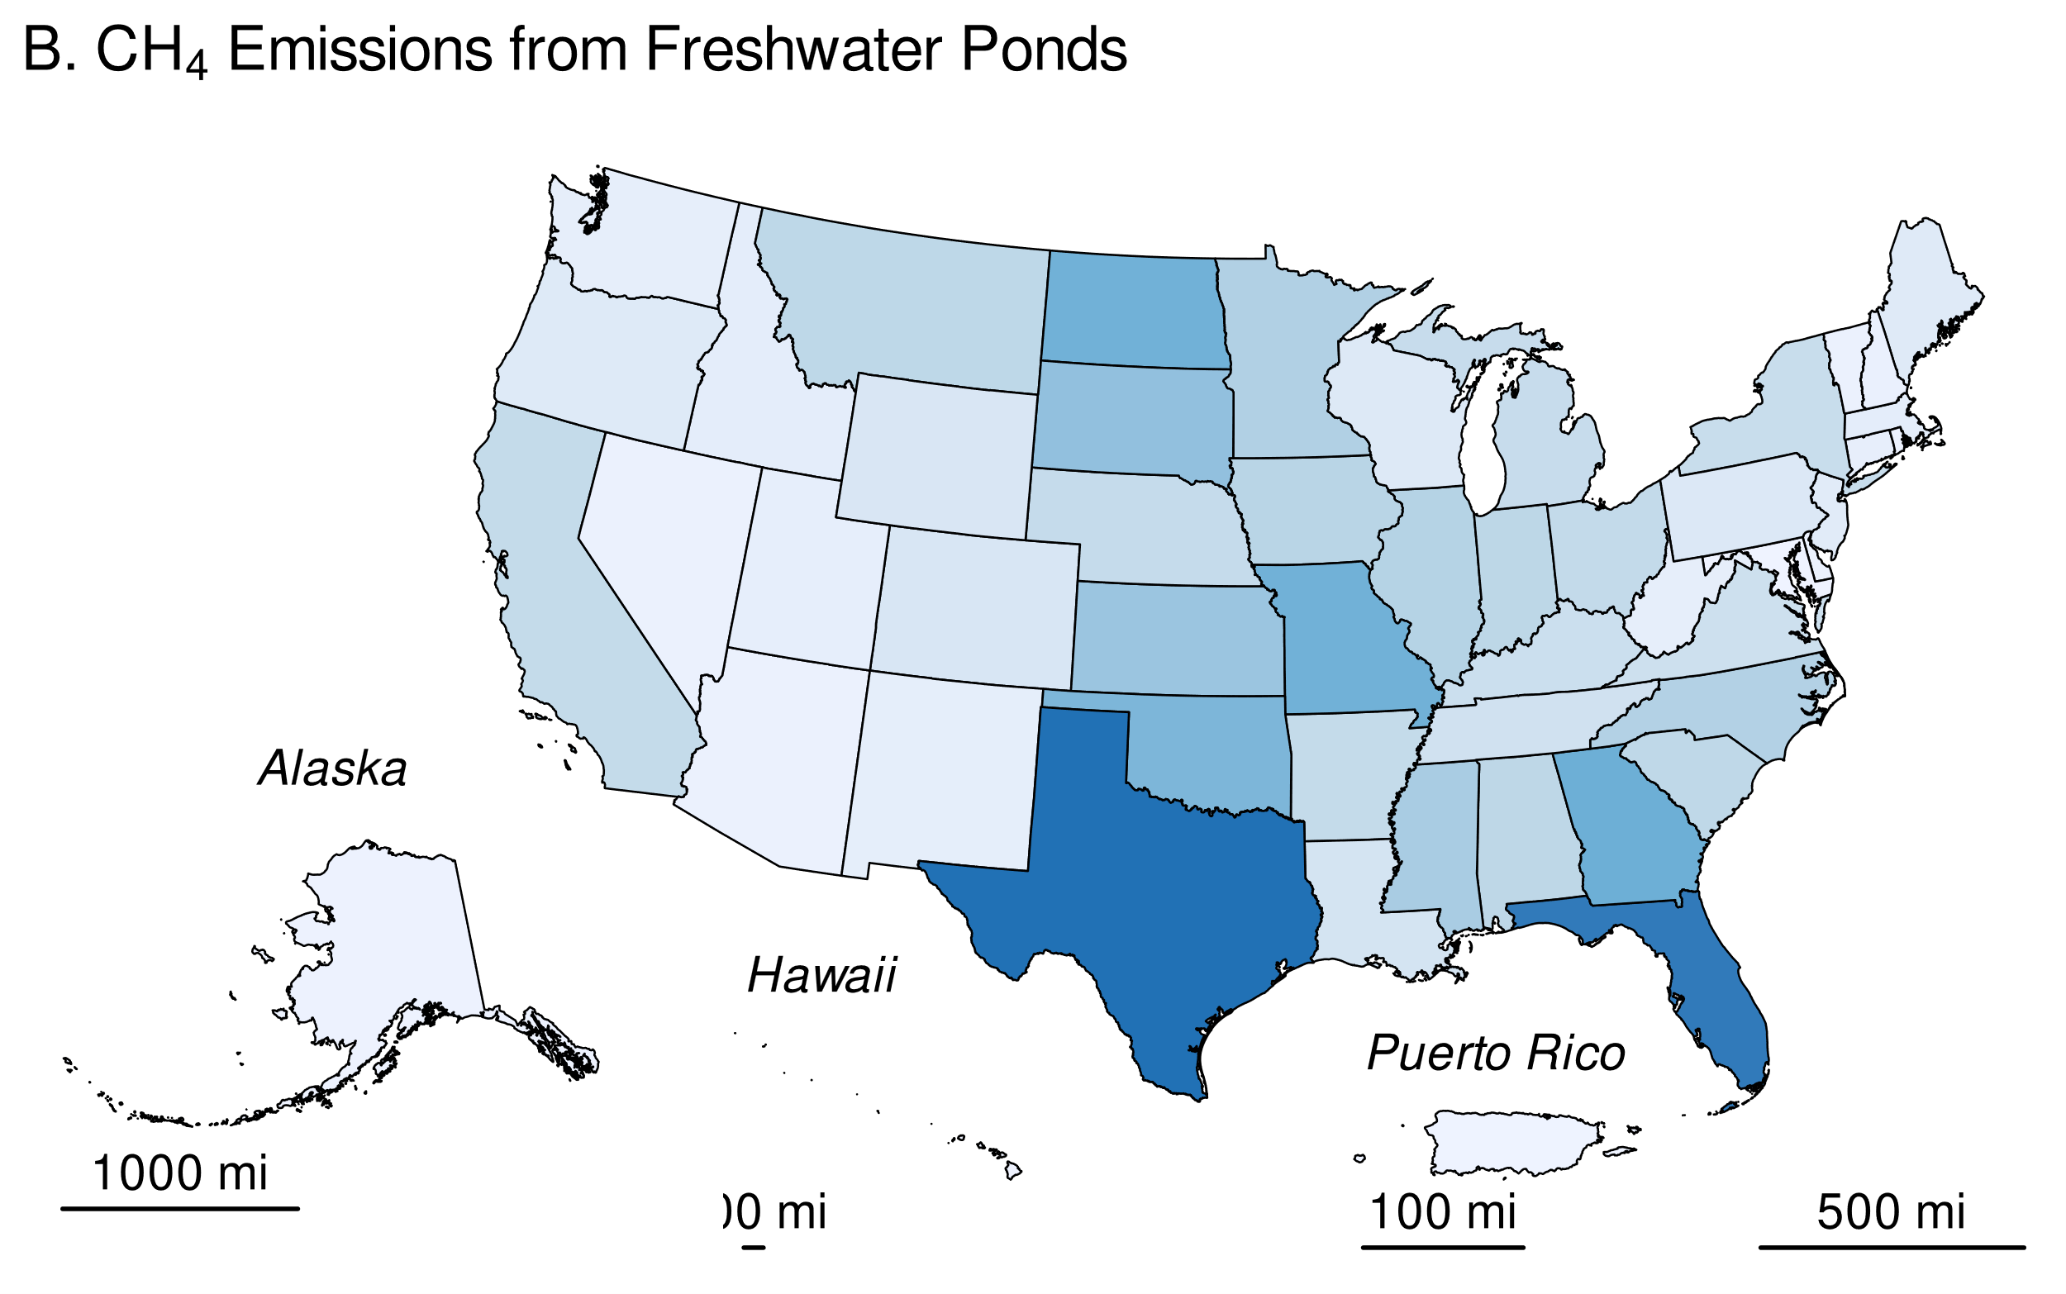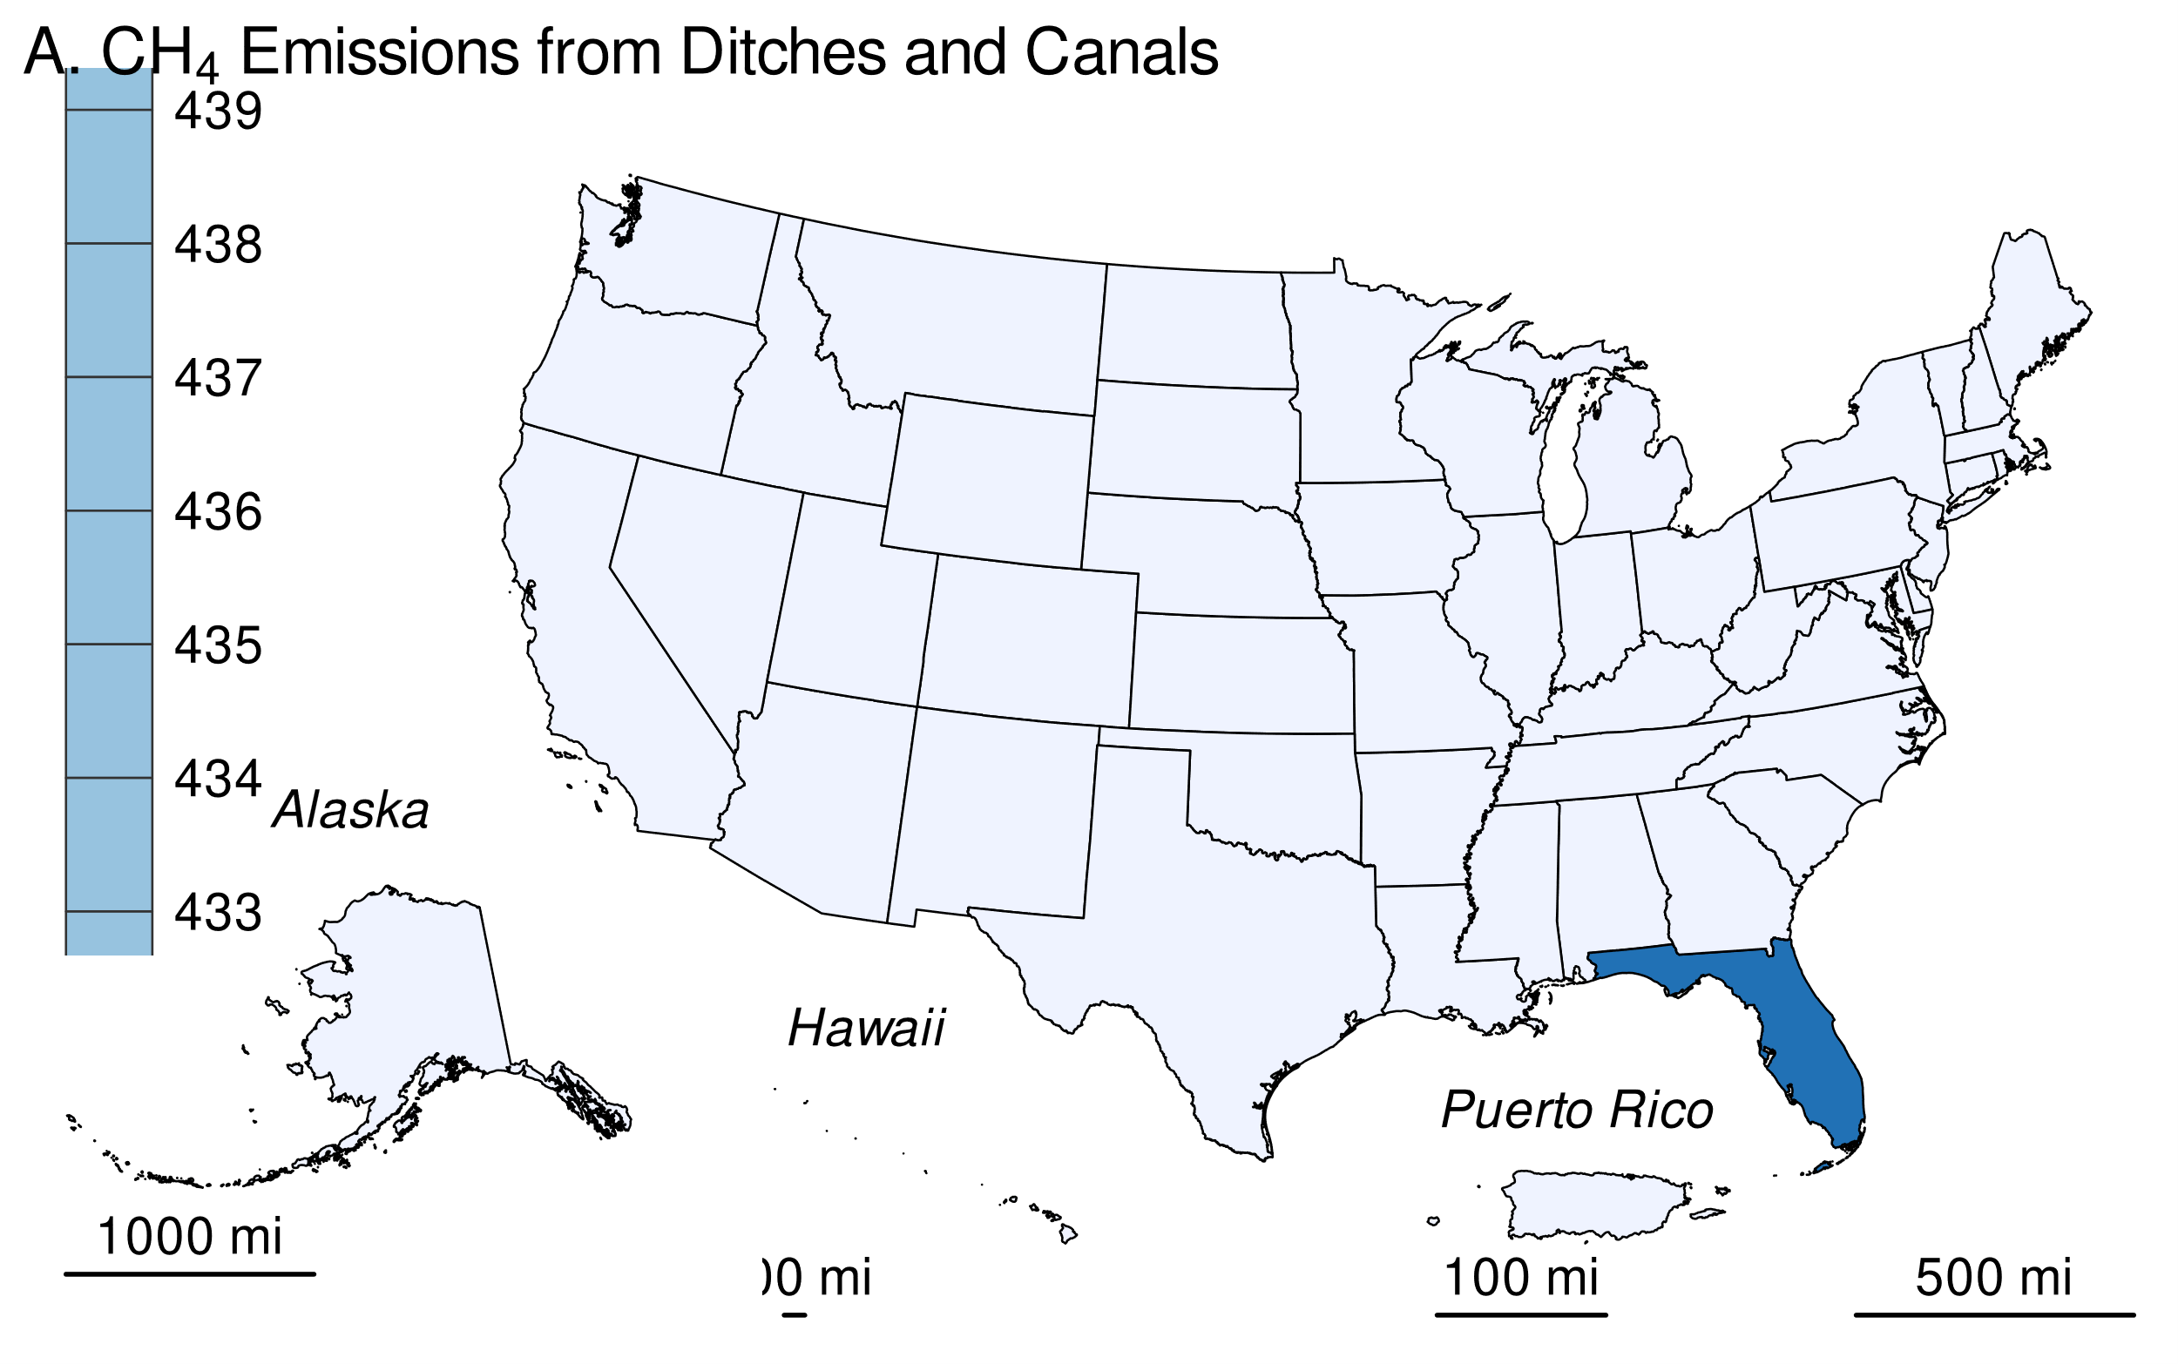

### Methodology and Time-Series Consistency

Estimates of CH4 emissions for other constructed waterbodies in flooded land remaining flooded Land follow the Tier 1 methodology in IPCC (2019). All calculations are performed at the state level and summed to obtain national estimates. Based on IPCC guidance, methane emissions from the surface of these flooded lands are calculated as the product of flooded land surface area and an emission factor (Table 6-90). Although literature data on greenhouse gas emissions from canals and ditches is relatively sparse, they have the highest default emission factor of all flooded land types (Table 6-90). Default emission factors for freshwater ponds are on the higher end of those for reservoirs. There are insufficient data to support climate-specific emission factors for ponds or canals and ditches. Downstream emissions are not inventoried for other constructed waterbodies because 1) many of these systems are not associated with dams (e.g., excavated ponds and ditches), and 2) there are insufficient data to derive downstream emission factors for other constructed waterbodies that are associated with dams (IPCC 2019).

#### 

Table 10: Table 6-90: IPCC (2019) Default CH4 Emission Factors for Surface Emission from Other Constructed Waterbodies in Flooded Land Remaining Flooded Land

| Other Constructed Waterbody | Surface emission factor (Mt CH<w:r><w:rPr><w:vertAlign w:val="subscript"></w:vertAlign></w:rPr><w:t xml:space="default">4</w:t></w:r> ha<w:r><w:rPr><w:vertAlign w:val="superscript"></w:vertAlign></w:rPr><w:t xml:space="default">-1</w:t></w:r> y<w:r><w:rPr><w:vertAlign w:val="superscript"></w:vertAlign></w:rPr><w:t xml:space="default">-1</w:t></w:r>) |
| --- | --- |
| freshwater pond | 0.1830 |
| canals and ditches | 0.4160 |

##### Area Estimates

Other constructed waterbodies were identified from the NHDWaterbody layer in the National Hydrography Dataset Plus V2 (NHD),[8] the National Inventory of Dams (NID), the National Wetlands Inventory (NWI),[9] the Navigable Waterways (NW) network,[10] and the EPA’s Safe Drinking Water Information System (SDWIS).[11] The NHD only covers the conterminous United States, whereas the NID, NW and NWI also include Alaska, Hawaii, District of Columbia, and Puerto Rico. The following paragraphs present the criteria used to identify other constructed waterbodies in the NHD, NW, and NWI.

Waterbodies in the NHDWaterbody layer that were greater than 20-years old, less than 8 ha in surface area, not identified as canal/ditch in NHD, and met any of the following criteria were considered freshwater ponds in flooded land remaining flooded land: 1) the waterbody was classified “Reservoir” in the NHDWaterbody layer, 2) the waterbody name in the NHDWaterbody layer included “Reservoir”, 3) the waterbody in the NHDWaterbody layer was located in close proximity (up to 100 m) to a dam in the NID, 4) the NHDWaterbody GNIS name was similar to nearby NID feature (between 100 m to 1000 m), the waterbody intersected a drinking water intake.

EPA assumes that all features included in the NW are subject to water-level management to maintain minimum water depths required for navigation and are therefore managed flooded lands. NW features that were less than 8 ha in surface area and not identified as canals/ditch (see below) were considered freshwater ponds. Only 2.1 percent of NW features met these criteria, and they were primarily associated with larger navigable waterways, such as lock chambers on impounded rivers.

NWI features were considered “managed” if they had a special modifier value indicating the presence of management activities (Figure 6-12). To be included in the flooded lands inventory, the managed flooded land had to be wet or saturated for at least one season per year (see “Water Regime” in Figure 6-12). NWI features that met these criteria, were less than 8 ha in surface area, and were not a canal/ditch (see below) were defined as freshwater ponds.

Any NWI or NHD feature that intersected a drinking water intake point from SDWIS was assumed to be “managed.” The rational being that a waterbody used as a source for public drinking water is typically managed in some capacity - by flow and/or volume control.

Canals and ditches, a subset of other constructed waterbodies, were identified in the NWI by their morphology. Unlike a natural water body, canals and ditches are typically narrow, linear features with abrupt angular turns. Figure 6-14 contrasts the unique shape of ditches/canals vs more natural water features.

###### 

**Figure 6-14: Left: NWI Features Identified as Canals/Ditches (pink) by Unique Narrow, Linear/Angular Morphology. Right: Non-Canal/Ditches with More Natural Morphology (blue)** 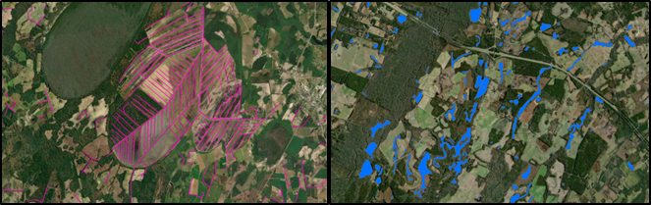

This morphology was identified systematically using shape attributes in a decision tree model. A training set of 752 features were identified as either “ditch” or “not ditch” using expert judgment. The training set was used to train a decision tree which was used to categorize millions of NWI features based on three shape attribute ratios (Figure 6-12).

###### 

Table 11: Table 6-91: Predictors used in Decision Tree to Identify Canal/Ditches

| Predictor |
| --- |
| Shape Length : # of Shape Vertices |
| Shape Area : Shape Length |
| Shape Area : # of Shape Vertices |

The decision tree built a model using 80 percent of the 752 training features and used the 20 percent to validate the model. The model was 93.1 percent accurate. Below are the validation results (Table 6-92).

###### 

Table 12: Table 6-92: Predictors used in Decision Tree to Identify Canal/Ditches

| Prediction | Ditch/Canal | Not Ditch/Canal |
| --- | --- | --- |
| Ditch/Canal | 49 | 5 |
| Not Ditch/Canal | 8 | 27 |

The decision tree model was then applied to the entire NWI dataset using the following shape attribute ratios (Figure 6-15).

###### 

**Figure 6-15: Structure of Decision Tree Used to Identify Canals/Ditches** 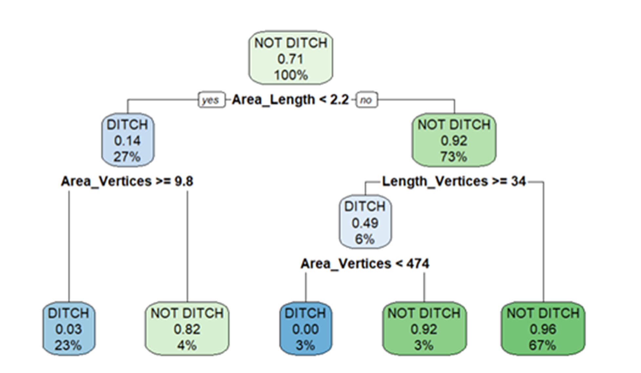

Surface areas for other constructed waterbodies were taken from NHD, NWI or the NW. If features from the NHD, NWI, or the NW datasets overlapped, these areas were erased. The first step was to take the final NWI flooded lands features and use it to identify overlapping NHD features. If the NHD feature had its center in a NWI feature, it was removed from analysis. Next, remaining NHD features were erased from any remaining overlapping NWI features. Final selections of NHD and NWI features were used to erase any overlapping NW waterbodies.

The age of other constructed waterbody features was determined by assuming the waterbody was created the same year as a nearby (up to 100 m) NID feature. If no nearby NID feature was identified, it was assumed the waterbody was greater than 20-years old throughout the time series. No canal/ditch features were associated with a nearby dam, therefore all canal/ditch features were assumed to be greater than 20-years old through the time series.

For the year 2022, this *Inventory* contains 1.6629104^{6} ha of freshwater ponds and 2.1097232^{6} ha of canals and ditches in flooded land remaining flooded land. The surface area of freshwater ponds increased by 1.0057673^{6} ha from 1990 to 2022 due to flooded lands matriculating from land converted to flooded land to flooded land remaining flooded land. All canals and ditches were assumed to be greater than 20-years old throughout the time series, thus the surface area of these flooded lands is constant throughout the time series.

###### 

Table 13: Table 6-93: National Surface Area Totals in Flooded Land Remaining Flooded Land - Other Constructed Waterbodies (ha)

|  | 1990 | 2005 | 2019 | 2020 | 2021 | 2022 | 2023 |
| --- | --- | --- | --- | --- | --- | --- | --- |
| canals and ditches | 2,109,723 | 2,109,723 | 2,109,723 | 2,109,723 | 2,109,723 | 2,109,723 | 2,109,723 |
| freshwater pond | 657,143 | 1,128,541 | 1,567,809 | 1,599,195 | 1,631,258 | 1,662,910 | 1,694,440 |
| **Total** | **2,766,866** | **3,238,264** | **3,677,532** | **3,708,918** | **3,740,981** | **3,772,634** | **3,804,163** |
| Note: Totals may not sum to due independent rounding. | | | | | | | |

Canals and ditches in the conterminous United States are most abundant in the Gulf Coast states and California (Figure 6-16A, Table ). Florida contains 19 percent of all U.S. canal and ditch surface area, most of which were constructed in the early 1900s for drainage, flood protection, and water storage purposes. Freshwater ponds are more widely distributed across the United States (Figure 6-16B, Table 6-95). Texas has the greatest surface area of freshwater ponds, equivalent to 8 percent of all freshwater pond surface area in the United States, closely followed by Florida.

###### 

This table is similar to that above, but contains the full time series. This was requested by John Steller on 4/29/2024. It will be written to “inventoryReportFloodedLandArea.xlsx”, sheet == FLRFL.ocwb.area.national.

Canals and ditches in the conterminous U.S. are most abundant in the Gulf Coast states and California (Fig. x-xxA.). FLorida contains 0.9877104 percent of all US canals and ditches. Texas has the greatest surface area of freshwater ponds, equivalent to 0.0785645 percent of all freshwater pond surface area in the United States, closely followed by Florida.

###### 

**Figure 6-16: 2023 Surface Area of A) Ditches and Canals and B) Freshwater Ponds in Flooded Land Remaining Flooded Land (ha)**

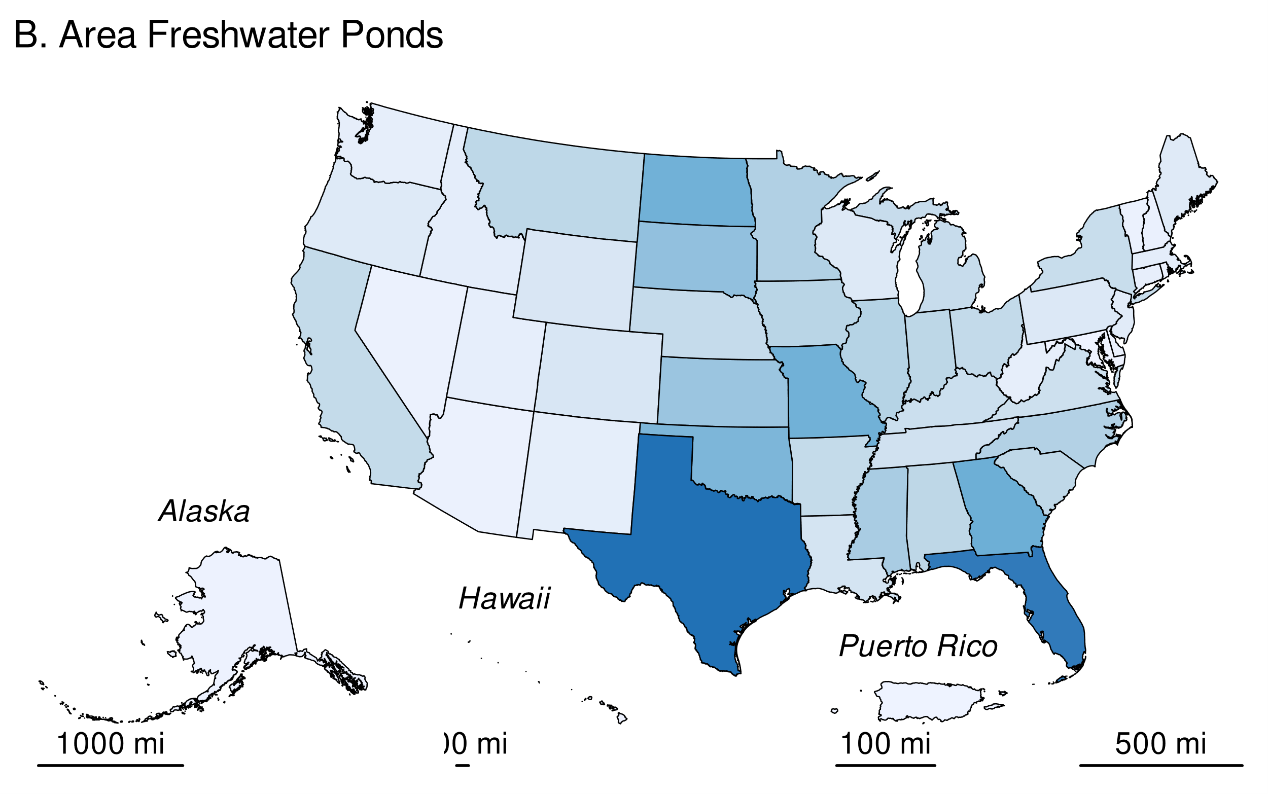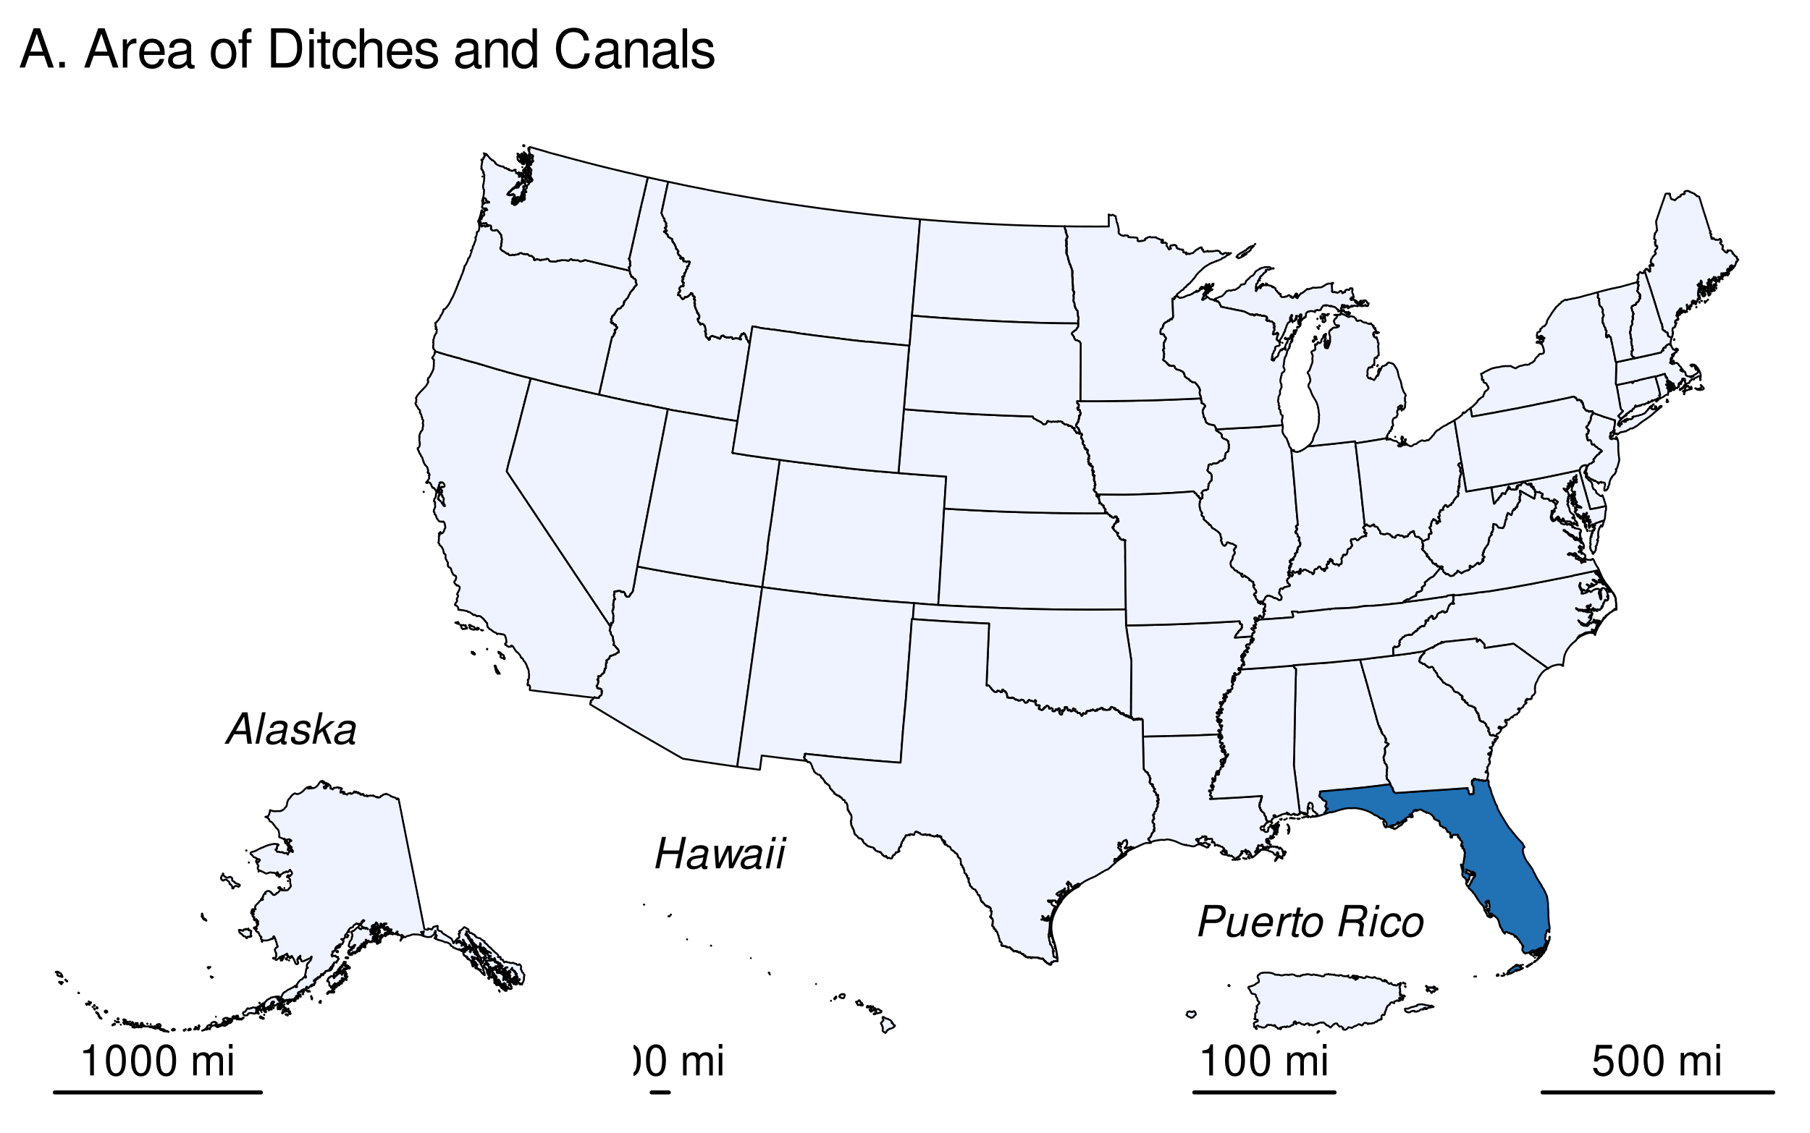

Table 14: Table 6-94: State Totals of Surface Area in Flooded Land Remaining Flooded Land—Canals and Ditches (ha)

| State | 1990 | 2005 | 2019 | 2020 | 2021 | 2022 | 2023 |
| --- | --- | --- | --- | --- | --- | --- | --- |
| Alabama | 18 | 18 | 18 | 18 | 18 | 18 | 18 |
| Alaska | 11 | 11 | 11 | 11 | 11 | 11 | 11 |
| Arizona | 246 | 246 | 246 | 246 | 246 | 246 | 246 |
| Arkansas | 660 | 660 | 660 | 660 | 660 | 660 | 660 |
| California | 563 | 563 | 563 | 563 | 563 | 563 | 563 |
| Colorado | 164 | 164 | 164 | 164 | 164 | 164 | 164 |
| Connecticut | 8 | 8 | 8 | 8 | 8 | 8 | 8 |
| Delaware | 1 | 1 | 1 | 1 | 1 | 1 | 1 |
| Florida | 2,083,796 | 2,083,796 | 2,083,796 | 2,083,796 | 2,083,796 | 2,083,796 | 2,083,796 |
| Georgia | 44 | 44 | 44 | 44 | 44 | 44 | 44 |
| Hawaii | 17 | 17 | 17 | 17 | 17 | 17 | 17 |
| Idaho | 190 | 190 | 190 | 190 | 190 | 190 | 190 |
| Illinois | 126 | 126 | 126 | 126 | 126 | 126 | 126 |
| Indiana | 94 | 94 | 94 | 94 | 94 | 94 | 94 |
| Iowa | 40 | 40 | 40 | 40 | 40 | 40 | 40 |
| Kansas | 17 | 17 | 17 | 17 | 17 | 17 | 17 |
| Kentucky | 59 | 59 | 59 | 59 | 59 | 59 | 59 |
| Louisiana | 932 | 932 | 932 | 932 | 932 | 932 | 932 |
| Maryland | 376 | 376 | 376 | 376 | 376 | 376 | 376 |
| Massachusetts | 16 | 16 | 16 | 16 | 16 | 16 | 16 |
| Michigan | 13,358 | 13,358 | 13,358 | 13,358 | 13,358 | 13,358 | 13,358 |
| Minnesota | 735 | 735 | 735 | 735 | 735 | 735 | 735 |
| Mississippi | 37 | 37 | 37 | 37 | 37 | 37 | 37 |
| Missouri | 209 | 209 | 209 | 209 | 209 | 209 | 209 |
| Montana | 238 | 238 | 238 | 238 | 238 | 238 | 238 |
| Nebraska | 62 | 62 | 62 | 62 | 62 | 62 | 62 |
| Nevada | 132 | 132 | 132 | 132 | 132 | 132 | 132 |
| New Hampshire | 0 | 0 | 0 | 0 | 0 | 0 | 0 |
| New Jersey | 83 | 83 | 83 | 83 | 83 | 83 | 83 |
| New Mexico | 750 | 750 | 750 | 750 | 750 | 750 | 750 |
| New York | 47 | 47 | 47 | 47 | 47 | 47 | 47 |
| North Carolina | 608 | 608 | 608 | 608 | 608 | 608 | 608 |
| North Dakota | 1 | 1 | 1 | 1 | 1 | 1 | 1 |
| Ohio | 4,280 | 4,280 | 4,280 | 4,280 | 4,280 | 4,280 | 4,280 |
| Oklahoma | 19 | 19 | 19 | 19 | 19 | 19 | 19 |
| Oregon | 262 | 262 | 262 | 262 | 262 | 262 | 262 |
| Pennsylvania | 13 | 13 | 13 | 13 | 13 | 13 | 13 |
| Puerto Rico | 20 | 20 | 20 | 20 | 20 | 20 | 20 |
| Rhode Island | 0 | 0 | 0 | 0 | 0 | 0 | 0 |
| South Carolina | 365 | 365 | 365 | 365 | 365 | 365 | 365 |
| South Dakota | 12 | 12 | 12 | 12 | 12 | 12 | 12 |
| Tennessee | 26 | 26 | 26 | 26 | 26 | 26 | 26 |
| Texas | 535 | 535 | 535 | 535 | 535 | 535 | 535 |
| Utah | 89 | 89 | 89 | 89 | 89 | 89 | 89 |
| Vermont | 16 | 16 | 16 | 16 | 16 | 16 | 16 |
| Virginia | 71 | 71 | 71 | 71 | 71 | 71 | 71 |
| Washington | 81 | 81 | 81 | 81 | 81 | 81 | 81 |
| West Virginia | 40 | 40 | 40 | 40 | 40 | 40 | 40 |
| Wisconsin | 146 | 146 | 146 | 146 | 146 | 146 | 146 |
| Wyoming | 109 | 109 | 109 | 109 | 109 | 109 | 109 |
| Total | **2,109,723** | **2,109,723** | **2,109,723** | **2,109,723** | **2,109,723** | **2,109,723** | **2,109,723** |
| Note: Totals may not sum due to independent rounding. | | | | | | | |

###### 

###### 

Table 15: Table 6-95: State Totals of Surface Area in Flooded Land Remaining Flooded Land—Freshwater Ponds (ha)

| State | 1990 | 2005 | 2019 | 2020 | 2021 | 2022 | 2023 |
| --- | --- | --- | --- | --- | --- | --- | --- |
| Alabama | 16,773 | 28,941 | 40,429 | 41,165 | 42,050 | 42,783 | 43,608 |
| Alaska | 680 | 1,202 | 1,683 | 1,721 | 1,764 | 1,794 | 1,818 |
| Arizona | 1,492 | 2,569 | 3,604 | 3,676 | 3,759 | 3,849 | 3,934 |
| Arkansas | 14,959 | 25,636 | 35,429 | 36,101 | 36,836 | 37,602 | 38,291 |
| California | 14,732 | 25,427 | 35,165 | 35,827 | 36,575 | 37,286 | 38,015 |
| Colorado | 7,879 | 13,445 | 18,711 | 19,094 | 19,469 | 19,903 | 20,271 |
| Connecticut | 2,980 | 4,975 | 6,859 | 7,010 | 7,116 | 7,258 | 7,393 |
| Delaware | 1,429 | 2,356 | 3,247 | 3,311 | 3,384 | 3,463 | 3,534 |
| District of Columbia | 5 | 6 | 8 | 8 | 8 | 8 | 8 |
| Florida | 48,718 | 83,680 | 116,564 | 118,858 | 121,281 | 123,686 | 126,083 |
| Georgia | 33,642 | 58,084 | 80,941 | 82,659 | 84,279 | 86,015 | 87,652 |
| Hawaii | 500 | 826 | 1,127 | 1,143 | 1,157 | 1,185 | 1,214 |
| Idaho | 3,978 | 6,755 | 9,243 | 9,426 | 9,578 | 9,789 | 9,968 |
| Illinois | 19,126 | 32,737 | 45,397 | 46,195 | 47,077 | 47,987 | 48,855 |
| Indiana | 17,367 | 29,402 | 40,935 | 41,746 | 42,510 | 43,311 | 44,134 |
| Iowa | 18,032 | 30,900 | 43,046 | 43,893 | 44,770 | 45,648 | 46,562 |
| Kansas | 24,818 | 42,713 | 59,057 | 60,328 | 61,542 | 62,722 | 63,890 |
| Kentucky | 12,288 | 21,127 | 29,346 | 29,912 | 30,514 | 31,112 | 31,769 |
| Louisiana | 9,381 | 15,906 | 22,111 | 22,547 | 23,026 | 23,512 | 23,918 |
| Maine | 5,650 | 9,812 | 13,571 | 13,824 | 14,054 | 14,325 | 14,570 |
| Maryland | 5 | 17 | 21 | 27 | 27 | 27 | 27 |
| Massachusetts | 3,888 | 6,531 | 8,889 | 9,077 | 9,261 | 9,462 | 9,641 |
| Michigan | 13,600 | 23,554 | 32,915 | 33,606 | 34,229 | 34,946 | 35,632 |
| Minnesota | 20,019 | 34,173 | 47,747 | 48,740 | 49,652 | 50,684 | 51,625 |
| Mississippi | 21,670 | 37,289 | 51,737 | 52,817 | 53,968 | 54,984 | 56,063 |
| Missouri | 33,109 | 57,147 | 79,405 | 80,998 | 82,712 | 84,190 | 85,756 |
| Montana | 16,703 | 28,849 | 40,241 | 41,018 | 41,852 | 42,682 | 43,457 |
| Nebraska | 14,599 | 25,245 | 34,836 | 35,602 | 36,338 | 36,998 | 37,724 |
| Nevada | 1,226 | 2,180 | 3,011 | 3,097 | 3,187 | 3,260 | 3,356 |
| New Hampshire | 1,630 | 2,796 | 3,905 | 3,983 | 4,051 | 4,124 | 4,175 |
| New Jersey | 4,813 | 8,275 | 11,504 | 11,717 | 11,978 | 12,187 | 12,379 |
| New Mexico | 3,372 | 5,663 | 7,992 | 8,160 | 8,307 | 8,462 | 8,607 |
| New York | 13,369 | 23,047 | 32,091 | 32,715 | 33,370 | 34,023 | 34,694 |
| North Carolina | 19,766 | 33,654 | 46,512 | 47,458 | 48,396 | 49,302 | 50,323 |
| North Dakota | 33,415 | 57,218 | 79,565 | 81,106 | 82,690 | 84,189 | 85,770 |
| Ohio | 15,031 | 26,002 | 36,103 | 36,842 | 37,586 | 38,261 | 38,958 |
| Oklahoma | 31,221 | 53,562 | 74,401 | 75,819 | 77,355 | 78,811 | 80,215 |
| Oregon | 5,682 | 9,736 | 13,695 | 13,992 | 14,331 | 14,584 | 14,863 |
| Pennsylvania | 6,745 | 11,405 | 15,662 | 15,991 | 16,325 | 16,634 | 16,910 |
| Puerto Rico | 203 | 331 | 457 | 473 | 485 | 503 | 509 |
| Rhode Island | 599 | 1,112 | 1,515 | 1,545 | 1,572 | 1,616 | 1,653 |
| South Carolina | 16,575 | 28,429 | 39,422 | 40,241 | 41,029 | 41,856 | 42,634 |
| South Dakota | 26,784 | 45,749 | 63,525 | 64,818 | 66,179 | 67,520 | 68,889 |
| Tennessee | 10,574 | 18,366 | 25,657 | 26,146 | 26,657 | 27,181 | 27,723 |
| Texas | 51,725 | 88,799 | 123,265 | 125,727 | 128,147 | 130,646 | 133,172 |
| Utah | 3,165 | 5,505 | 7,574 | 7,704 | 7,864 | 8,016 | 8,170 |
| Vermont | 1,298 | 2,246 | 3,064 | 3,115 | 3,183 | 3,266 | 3,329 |
| Virginia | 11,651 | 20,199 | 28,185 | 28,741 | 29,351 | 29,891 | 30,448 |
| Washington | 3,238 | 5,703 | 7,772 | 7,952 | 8,128 | 8,277 | 8,405 |
| West Virginia | 3,195 | 5,525 | 7,696 | 7,856 | 7,984 | 8,117 | 8,284 |
| Wisconsin | 6,059 | 10,474 | 14,543 | 14,842 | 15,155 | 15,470 | 15,732 |
| Wyoming | 7,786 | 13,262 | 18,427 | 18,828 | 19,161 | 19,504 | 19,831 |
| Total | **657,143** | **1,128,541** | **1,567,809** | **1,599,195** | **1,631,258** | **1,662,910** | **1,694,440** |
| Note: Totals may not sum due to independent rounding. | | | | | | | |

###### 

### Uncertainty

Uncertainty in estimates of CH4 emissions from other constructed waterbodies (ponds, canals/ditches) in flooded land remaining flooded land (Table 6-96) are estimated using IPCC Approach 2 and include uncertainty in the default emission factors and the flooded land area inventory. Uncertainty in default emission factors is provided in the *2019 Refinement to the 2006 IPCC Guidelines* (IPCC 2019). Uncertainties in the spatial data include 1) uncertainty in area estimates from the NHD, NWI, and NW, and 2) uncertainty in the location of dams in the NID. Overall uncertainties in these spatial datasets are unknown, but uncertainty for remote sensing products is assumed to be ± 10 to 15 percent based on IPCC guidance (IPCC 2003). An uncertainty range of ± 15 percent for the flooded land area estimates is assumed and is based on expert judgment.

#### 

### QA/QC and Verification

The National Hydrography Data (NHD) is managed by the USGS in collaboration many other federal, state, and local entities. Extensive QA/QC procedures are incorporated into the curation of the NHD. The National Inventory of Dams (NID) is maintained by the U.S. Army Corps of Engineers (USACE) in collaboration with the Federal Emergency Management Agency (FEMA) and state regulatory offices. USACE resolves duplicative and conflicting data from 68 data sources, which helps obtain the more complete, accurate, and updated NID.[12]. The Navigable Waterways (NW) dataset is part of the U.S. Department of Transportation (USDOT)/Bureau of Transportation Statistics (BTS) National Transportation Atlas Database (NTAD). The NW is a comprehensive network database of the nation’s navigable waterways updated on a continuing basis. U.S. Fish and Wildlife Service is the principal agency in charge of wetland mapping including the National Wetlands Inventory (NWI). Quality and consistency of the Wetlands Layer is supported by federal wetlands mapping and classification standards, which were developed under the oversight of the Federal Geographic Data Committee (FGDC) with input by the FGDC Wetlands Subcommittee. This dataset is part of the FGDC Water-Inland Theme, which is co-chaired by the FWS and the U.S. Geological Survey. The EPA’s Safe Drinking Water Information System (SDWIS) tracks information on drinking water contamination levels as required by the 1974 Safe Drinking Water Act and its 1986 and 1996 amendments.

General QA/QC procedures were applied to activity data, documentation, and emission calculations consistent with the U.S. Inventory QA/QC plan, which is in accordance with Vol. 1 Chapter 6 of 2006 IPCC Guidelines (see Annex 8 for more details). All calculations were executed independently in Excel and R. Ten percent of state and national totals were randomly selected for comparison between the two approaches to ensure there were no computational errors.

### Recalculations Discussion

The EPA’s SDWIS is a new data source used in the current (1990 through 2022) *Inventory*. The assumption is that any waterbody used as a public drinking water source is managed in some capacity—by flow and/or volume control. This data source added 54 features totaling 173 ha of other constructed waterbodies.

The National Inventory of Dams (NID) data are updated regularly. The version of NID used for the current (1990 through 2022) *Inventory* contains 47 new dams and updated values for “year of dam completion” for 975 dams relative to the previous (1990 through 2021) Inventory data. Similarly, the National Wetlands Inventory (NWI) is periodically updated. The NWI version used for the current *Inventory* has major updates for MS, ND, NM, and MT.

The net effect of these recalculations was an average annual decrease in CH4 emission estimates from other constructed waterbodies of 2.7 MMT CO2 Eq., or 17 percent, over the time series from 1990 to 2021 compared to the previous *Inventory*.

### Planned Improvements

Default emission factors for canals/ditches were derived from a global dataset that include few measurements from U.S. systems. The EPA plans to conduct a literature survey to determine if sufficient data are available to derive a country-specific emission factor for the 1990 through 2024 *Inventory* submission.

Canal and ditch surface area included here may overlap with ditches and canals included in CH4 emission estimates for ditches draining inland organic soils (IPCC 2013, section 2.2.2.1). EPA plans to reconcile ditch/canal surface areas between the two managed land types (flooded land vs drained inland organic soils) in the next (i.e., 1990 through 2023) *Inventory*.

Features less than 8 ha in the NW that were not identified as Canal/Ditch were defined as freshwater ponds. Many of these features are lock chambers connected to an upstream reservoir. These systems likely have emission rates more similar to a reservoir than freshwater pond. In the next (1990 through 2023) *Inventory* these systems will be classified as reservoirs.

# Land Converted to Flooded Land

Flooded lands are defined as water bodies where human activities have 1) caused changes in the amount of surface area covered by water, typically through water level regulation (e.g., constructing a dam), 2) waterbodies where human activities have changed the hydrology of existing natural waterbodies thereby altering water residence times and/or sedimentation rates, in turn causing changes to the natural production of greenhouse gases, and 3) waterbodies that have been created by excavation, such as canals, ditches and ponds (IPCC 2019). Flooded lands include waterbodies with seasonally variable degrees of inundation but would be expected to retain some inundated area throughout the year under normal conditions.

Flooded lands are broadly classified as “reservoirs” or “other constructed waterbodies” (IPCC 2019). Reservoirs are defined as flooded land greater than 8 ha and includes the seasonally flooded land on the perimeter of permanently flooded land (i.e., inundation areas). IPCC guidance (IPCC 2019) provides default emission factors for reservoirs and several types of “other constructed waterbodies” including freshwater ponds and canals/ditches.

Land that has been flooded for 20 years or greater is defined as flooded land remaining flooded land and land flooded for less than 20 years is defined as land converted to flooded land. The distinction is based on literature reports that CO2 and CH4 emissions are high immediately following flooding as labile organic matter is rapidly degraded but decline to a steady background level approximately 20 years after flooding (Abril et al. 2005, Barros et al. 2011, Teodoru et al. 2012). Both CO2 and CH4 emissions are estimated for land converted to flooded land.

Nitrous oxide emissions from flooded lands are largely related to inputs of organic or inorganic nitrogen from the watershed. These inputs from runoff/leaching/deposition are largely driven by anthropogenic activities such as land-use change, wastewater disposal or fertilizer application in the watershed or application of fertilizer or feed in aquaculture. These emissions are not included here to avoid double-counting N2O emissions which are captured in other source categories, such as indirect N2O emissions from managed soils (Section 5.4, Agricultural Soil Management) and wastewater management (Section 7.2, Wastewater Treatment and Discharge).

Reservoirs are designed to store water for a wide range of purposes including hydropower, flood control, drinking water, and irrigation. The permanently wetted portion of reservoirs are typically surrounded by periodically inundated land referred to as a “drawdown zone” or “inundation area.” Greenhouse gas emissions from inundation areas are considered significant and similar per unit area to the emissions from the water surface and are therefore included in the total reservoir surface area when estimating greenhouse gas emissions from flooded land. Lakes converted into reservoirs without substantial changes in water surface area or water residence times are not considered to be managed flooded land (see Area Estimates below) (IPCC 2019). In 2022, the United States and Puerto Rico contained 72,461 ha of reservoir surface area in land converted to flooded land (see Methodology and Time-Series Consistency below for calculation details) distributed across all six of the aggregated climate zones used to define flooded land emission factors (Figure 6-17) (IPCC 2019).

In 2022, the United States and Puerto Rico hosted 9.9622021^{4} ha of reservoir surface area in land converted to flooded land (see Methodology and Time-Series Consistency below for calculation details) distributed across 6 of the aggregated climate zones used to define flooded land emission factors (Figure 6-17) (IPCC 2019).

## Emissions from Land Converted to Flooded Land - Reservoirs

### 

**Figure 6-17: U.S. Reservoirs (black polygons) in the Land Converted to Flooded Land Category in 2023**

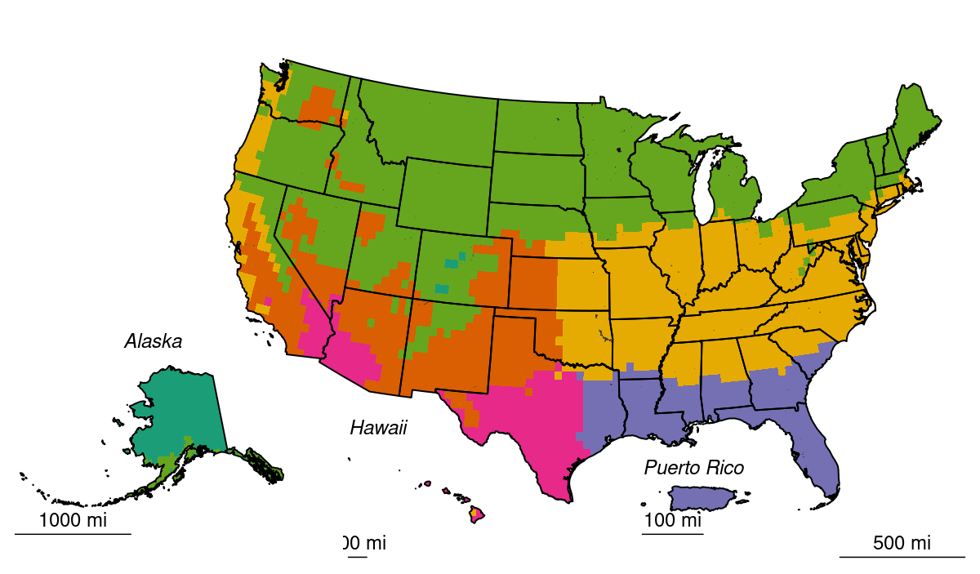

Methane and CO2 are produced in reservoirs through the natural breakdown of organic matter. Per unit area emission rates tend to scale positively with temperature and system productivity (i.e., abundance of algae). Greenhouse gases produced in reservoirs can be emitted directly from the water surface and inundation areas or as greenhouse gas-enriched water passes through the dam and the downstream river. Sufficient information exists to estimate downstream CH4 emissions using Tier 1 IPCC guidance (IPCC 2019), but no guidance is provided for downstream CO2 emissions. Table 6-101 and Table 6-102 below summarize nationally aggregated CH4 and CO2 emissions from reservoirs in land converted to flooded land. The decrease in CO2 and CH4 emissions through the time series is attributable to reservoirs matriculating from the land converted to flooded land category into the flooded land remaining flooded land category. Emissions have been stable since 2005, reflecting the low rate of new flooded land creation over the past 17 years.

### 

Table 16: Table 6-101: CH4 Emissions from Land Converted to Flooded Land—Reservoirs (MMT CO2 Eq.)

| Activity | 1990 | 2005 | 2019 | 2020 | 2021 | 2022 | 2023 |
| --- | --- | --- | --- | --- | --- | --- | --- |
| surface | 3 | 1 | 0 | 0 | 0 | 0 | 0 |
| downstream | 0 | 0 | 0 | 0 | 0 | 0 | 0 |

Table 17: Table 6-102: CH4 Emissions from Land Converted to Flooded Land—Reservoirs (kt CH4)

| Activity | 1990 | 2005 | 2019 | 2020 | 2021 | 2022 | 2023 |
| --- | --- | --- | --- | --- | --- | --- | --- |
| surface | 98 | 21 | 11 | 11 | 11 | 10 | 10 |
| downstream | 9 | 2 | 1 | 1 | 1 | 1 | 1 |

Table 18: Table 6-103: CO2 Emissions from Land Converted to Flooded Land—Reservoirs (MMT CO2)

| Activity | 1990 | 2005 | 2019 | 2020 | 2021 | 2022 | 2023 |
| --- | --- | --- | --- | --- | --- | --- | --- |
| surface | 3.8 | 0.9 | 0.5 | 0.5 | 0.5 | 0.4 | 0.4 |

Table 19: Table 6-104: CO2 Emissions from Land Converted to Flooded Land—Reservoirs (MMT C)

| Activity | 1990 | 2005 | 2019 | 2020 | 2021 | 2022 | 2023 |
| --- | --- | --- | --- | --- | --- | --- | --- |
| surface | 3.8 | 0.9 | 0.5 | 0.5 | 0.5 | 0.4 | 0.4 |

Methane and CO2 emissions from reservoirs in Minnesota were 8-fold greater than from any other state (Figure 6-18 and Table 6-105). This is attributed to 17 reservoirs created in Minnesota after 2001 which impounded 5.3985116^{4} ha of water, 0.9592089 percent of which is located in Mille Lacs lake.

North Dakota is the second largest source of CO2 and CH4 from reservoirs in land converted to flooded land. Over 0.9800364 percent of land converted to flooded land reservoir surface area in North Dakota is attributed to Devils Lake. Both Mille Lacs and Devils Lakes are natural waterbodies provisioned with dams for water level management.

### 

**Figure 6-18: 2022 A) CH4 and B) CO2 Emissions from U.S. Reservoirs in Land Converted to Flooded Land**

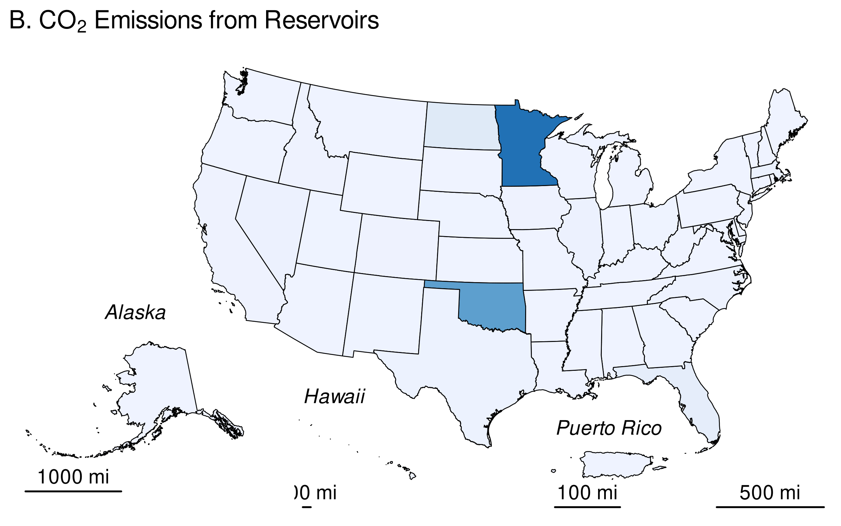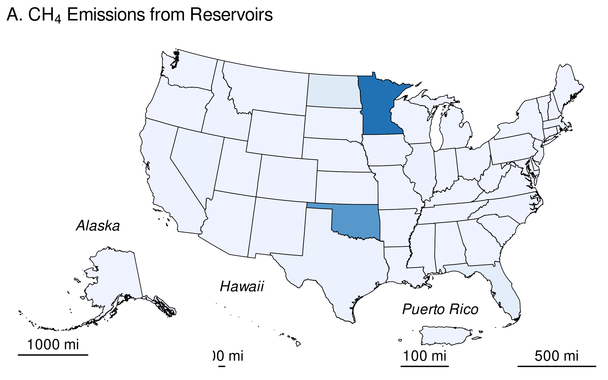

Table 20: Table 6-105: Methane and **CO2** Emissions from Reservoirs in Land Converted to Flooded Land in 2023 (kt **CH4**; kt **CO2**)

| **State** | **CH4** | | |  |
| --- | --- | --- | --- | --- |
| Surface | Downstream | Total | **CO2***a* |
| Alabama | + | + | + | + |
| Alaska | + | + | + | + |
| Arizona | + | + | + | + |
| Arkansas | + | + | + | + |
| California | + | + | + | 1.5 |
| Colorado | + | + | + | 1.6 |
| Connecticut | + | + | + | + |
| Delaware | + | + | + | + |
| District of Columbia | + | + | + | + |
| Florida | + | + | + | 13.9 |
| Georgia | + | + | + | 0.8 |
| Hawaii | + | + | + | + |
| Idaho | + | + | + | 1.5 |
| Illinois | + | + | + | 4.1 |
| Indiana | + | + | + | + |
| Iowa | + | + | + | 1.9 |
| Kansas | + | + | + | + |
| Kentucky | + | + | + | + |
| Louisiana | + | + | + | + |
| Maine | + | + | + | + |
| Maryland | + | + | + | + |
| Massachusetts | + | + | + | 4.9 |
| Michigan | + | + | + | 0.5 |
| Minnesota | 4.6 | + | 5.1 | 205.0 |
| Mississippi | + | + | + | + |
| Missouri | + | + | + | + |
| Montana | + | + | + | + |
| Nebraska | + | + | + | 0.9 |
| Nevada | + | + | + | 3.7 |
| New Hampshire | + | + | + | + |
| New Jersey | + | + | + | + |
| New Mexico | + | + | + | 1.1 |
| New York | + | + | + | + |
| North Carolina | + | + | + | 2.1 |
| North Dakota | 0.5 | + | 0.6 | 22.5 |
| Ohio | + | + | + | 1.0 |
| Oklahoma | 3.6 | + | 4.0 | 152.5 |
| Oregon | + | + | + | + |
| Pennsylvania | + | + | + | 0.5 |
| Puerto Rico | + | + | + | + |
| Rhode Island | + | + | + | + |
| South Carolina | + | + | + | + |
| South Dakota | + | + | + | + |
| Tennessee | + | + | + | 0.5 |
| Texas | + | + | + | 3.6 |
| Utah | + | + | + | 0.8 |
| Vermont | + | + | + | + |
| Virginia | + | + | + | + |
| Washington | + | + | + | + |
| West Virginia | + | + | + | + |
| Wisconsin | + | + | + | + |
| Wyoming | + | + | + | 0.5 |
| Total | 10 | 1 | 11 | 428 |
| + Indicates values less than 0.5 kt. | | | | |
| *a*CO<sub>2</sub>: Only surface CO<sub>2</sub> emissions are included in the *Inventory*. | | | | |

### Methodology and Time-Series Consistency

Estimates of CH4 and CO2 emissions for reservoirs in land converted to flooded land follow the Tier 1 methodology in the IPCC guidance (IPCC 2019). All calculations are performed at the state level and summed to obtain national estimates. Emissions from the surface of these flooded lands are calculated as the product of flooded land surface area and a climate-specific emission factor (Table 6-106). Downstream CH4 emissions are calculated as 9 percent of the surface CH4 emission (Tier 1 default). The IPCC guidance (IPCC 2019) does not address downstream CO2 emissions, presumably because there are insufficient data in the literature to estimate this emission pathway.

The IPCC default surface emission factors are derived from model-predicted (G-res model, Prairie et al. 2017) emission rates for all reservoirs in the Global Reservoir and Dam (GRanD) database (Lehner et al. 2011). Predicted emission rates were aggregated by the 11 IPCC climate zones (IPCC 2019, Table 7A.2) which were collapsed into six climate zones using a regression tree approach. All six aggregated climate zones are present in the United States.

#### 

Table 21: Table 6-106: IPCC (2019) Default CH4 and CO2 Emission Factors for Surface Emission from Reservoirs in Land Converted to Flooded Land

|  | **Surface emission factor** | |
| --- | --- | --- |
| Climate | Mt CH<w:r><w:rPr><w:vertAlign w:val="subscript"></w:vertAlign></w:rPr><w:t xml:space="default">4</w:t></w:r> ha<w:r><w:rPr><w:vertAlign w:val="superscript"></w:vertAlign></w:rPr><w:t xml:space="default">-1</w:t></w:r> y<w:r><w:rPr><w:vertAlign w:val="superscript"></w:vertAlign></w:rPr><w:t xml:space="default">-1</w:t></w:r> | Mt CO<w:r><w:rPr><w:vertAlign w:val="subscript"></w:vertAlign></w:rPr><w:t xml:space="default">2</w:t></w:r> ha<w:r><w:rPr><w:vertAlign w:val="superscript"></w:vertAlign></w:rPr><w:t xml:space="default">-1</w:t></w:r> y<w:r><w:rPr><w:vertAlign w:val="superscript"></w:vertAlign></w:rPr><w:t xml:space="default">-1</w:t></w:r> |
| Boreal | 0.0277 | 3.4467 |
| Cool Temperate | 0.0847 | 3.7400 |
| Warm Temperate Dry | 0.1956 | 6.2333 |
| Warm Temperate Moist | 0.1275 | 5.3533 |
| Tropical Dry/Montane | 0.3923 | 10.8167 |
| Tropical Moist/Wet | 0.2516 | 10.1567 |
| Note: downstream CH<sub>4</sub> emissions are calculated as 9 percent of surface emissions. Downstream emissions are not calculated for CO<sub>2</sub>. | | |

#### Area estimates

U.S. reservoirs were identified from the NHDWaterbody layer in the National Hydrography Dataset Plus V2 (NHD),[13] the National Inventory of Dams (NID),[14] the National Wetlands Inventory (NWI),[15] and the Navigable Waterways (NW) network,[16] and the EPA’s Safe Drinking Water Information System (SDWIS).[17] The NHD only covers the conterminous United States, whereas the NID, NW and NWI also include Alaska, Hawaii, and Puerto Rico. The following paragraphs present the criteria used to identify other constructed waterbodies in the NHD, NW, and NWI.

Waterbodies in the NHDWaterbody layer that were less than or equal to 20-years old, greater than or equal to 8 ha in surface area, not identified as canal/ditch in NHD, and met any of the following criteria were considered reservoirs in land converted to flooded land: 1) the waterbody was classified “Reservoir” in the NHDWaterbody layer, 2) the waterbody name in the NHDWaterbody layer included “Reservoir”, 3) the waterbody in the NHDWaterbody layer was located in close proximity (up to 100 m) to a dam in the NID, 4) the NHDWaterbody GNIS name was similar to nearby NID feature (between 100 m to 1000 m).

EPA assumes that all features included in the NW are subject to water-level management to maintain minimum water depths required for navigation and are therefore managed flooded lands. NW features greater than 8 ha in surface area are defined as reservoirs.

NWI features were considered “managed” if they had a special modifier value indicating the presence of management activities (Figure 6-19). To be included in the flooded lands inventory, the managed flooded land had to be wet or saturated for at least one season per year (see ‘Water Regime’ in Figure 6-19). NWI features that met these criteria, were greater than 8 ha in surface area, and were not a canal/ditch (see emissions from land converted to flooded land–other constructed waterbodies) were defined as reservoirs.

Any NWI or NHD feature that intersected a drinking water intake point from SDWIS was assumed to be “managed.” The rational being that a waterbody used as a source for public drinking water is typically managed in some capacity - by flow and/or volume control.

Surface areas for identified flooded lands were taken from NHD, NWI or the NW. If features from the NHD, NWI, or the NW datasets overlapped, duplicate areas were erased. The first step was to take the final NWI flooded lands features and use it to identify overlapping NHD features. If the NHD feature had its center in a NWI feature, it was removed from analysis. Next, remaining NHD features were erased from any remaining overlapping NWI features. Final selections of NHD and NWI features were used to erase any overlapping NW waterbodies.

Reservoir age was determined by assuming they were created the same year as a nearby (up to 100 m) NID feature. If no nearby NID feature was identified, it was assumed the feature was greater than 20-years old throughout the time series. Only reservoirs less than or equal to 20-years old are included in land converted to flooded land.

###### 

**Figure 6-19: Selected Features from NWI that meet Flooded Lands Criteria** 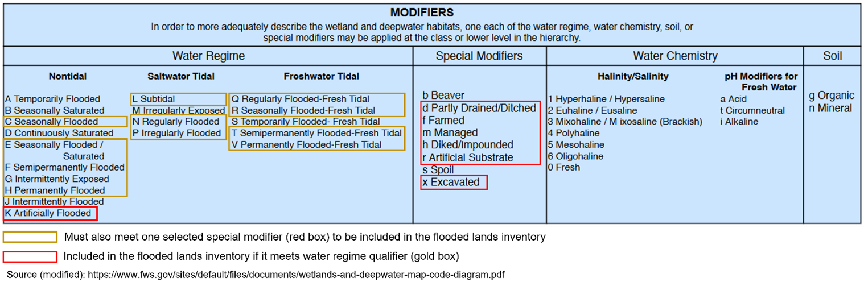

IPCC (2019) allows for the exclusion of managed waterbodies from the inventory if the water surface area or residence time was not substantially changed by the construction of the dam. The guidance does not quantify what constitutes a “substantial” change, but here EPA excludes the U.S. Great Lakes from the inventory based on expert judgment that neither the surface area nor water residence time was substantially altered by their associated dams.

Reservoirs were disaggregated by state (using boundaries from the 2016 U.S. Census Bureau[18]) and climate zone. Downstream and surface emissions for cross-state reservoirs were allocated to states based on the surface area that the reservoir occupied in each state. Only the U.S. portion of reservoirs that cross country borders were included in the Inventory.

The surface area of reservoirs in land converted to flooded land decreased by nearly 90 percent from 1990 to 2022 (Table 6-107). This is due to reservoirs that were less than 20-years old at the beginning of time series entering the flooded land remaining flooded land category when they exceeded 20 years of age. The rate at which flooded land has aged out of the land converted to flooded land category has outpaced the rate of new dam construction. New dam construction has slowed considerably during the time series with only nine new dams constructed in 2022,[19] versus 552 in 1990 (Figure 6-20).

##### 

Table 22: Table 6-107: National Totals of Reservoir Surface Area in Land Converted to Flooded Land (thousands of ha)

| Surface Area (thousands of ha) | 1990 | 2005 | 2019 | 2020 | 2021 | 2022 | 2023 |
| --- | --- | --- | --- | --- | --- | --- | --- |
| reservoir | 679.1 | 177.0 | 109.0 | 107.5 | 105.6 | 99.6 | 97.0 |

##### 

**Figure 6-20: Number of Dams Built per Year from 1990 through 2023**



##### TABLE:: Flooded Land Area for LCFL Reservoirs by State: abbreviated time series–>

Table 23: Table 6-108: State Breakdown of Reservoir Surface Area in Land Converted to Flooded Land (thousands of ha)

| State | 1990 | 2005 | 2019 | 2020 | 2021 | 2022 | 2023 |
| --- | --- | --- | --- | --- | --- | --- | --- |
| Alabama | 9 | 0 | 0 | 0 | 0 | 0 | 0 |
| Alaska | 1 | 0 | 0 | 0 | 0 | 0 | 0 |
| Arizona | 0 | 0 | 0 | 0 | 0 | 0 | 0 |
| Arkansas | 34 | 3 | 0 | 0 | 0 | 0 | 0 |
| California | 18 | 2 | 0 | 0 | 0 | 0 | 0 |
| Colorado | 7 | 1 | 0 | 0 | 0 | 0 | 0 |
| Connecticut | 1 | 1 | 0 | 0 | 0 | 0 | 0 |
| Delaware | 0 | 0 | 0 | 0 | 0 | 0 | 0 |
| District of Columbia | 0 | 0 | 0 | 0 | 0 | 0 | 0 |
| Florida | 11 | 4 | 2 | 2 | 2 | 1 | 1 |
| Georgia | 16 | 0 | 0 | 0 | 0 | 0 | 0 |
| Hawaii | 0 | 0 | 0 | 0 | 0 | 0 | 0 |
| Idaho | 18 | 1 | 0 | 0 | 0 | 0 | 0 |
| Illinois | 49 | 39 | 1 | 1 | 1 | 1 | 1 |
| Indiana | 10 | 0 | 0 | 0 | 0 | 0 | 0 |
| Iowa | 10 | 5 | 1 | 1 | 0 | 0 | 0 |
| Kansas | 14 | 0 | 0 | 0 | 0 | 0 | 0 |
| Kentucky | 4 | 0 | 0 | 0 | 0 | 0 | 0 |
| Louisiana | 10 | 4 | 1 | 1 | 0 | 0 | 0 |
| Maine | 14 | 4 | 0 | 0 | 0 | 0 | 0 |
| Maryland | 1 | 0 | 0 | 0 | 0 | 0 | 0 |
| Massachusetts | 1 | 1 | 1 | 1 | 1 | 1 | 1 |
| Michigan | 12 | 1 | 0 | 0 | 0 | 0 | 0 |
| Minnesota | 11 | 10 | 59 | 59 | 59 | 54 | 55 |
| Mississippi | 6 | 3 | 0 | 0 | 0 | 0 | 0 |
| Missouri | 18 | 1 | 0 | 0 | 0 | 0 | 0 |
| Montana | 17 | 4 | 2 | 2 | 2 | 2 | 0 |
| Nebraska | 5 | 1 | 0 | 0 | 0 | 0 | 0 |
| Nevada | 2 | 1 | 0 | 0 | 0 | 0 | 0 |
| New Hampshire | 0 | 0 | 0 | 0 | 0 | 0 | 0 |
| New Jersey | 1 | 1 | 0 | 0 | 0 | 0 | 0 |
| New Mexico | 4 | 2 | 1 | 1 | 1 | 1 | 0 |
| New York | 15 | 13 | 0 | 0 | 0 | 0 | 0 |
| North Carolina | 12 | 1 | 0 | 0 | 0 | 0 | 0 |
| North Dakota | 44 | 8 | 6 | 6 | 6 | 6 | 6 |
| Ohio | 7 | 1 | 0 | 0 | 0 | 0 | 0 |
| Oklahoma | 40 | 32 | 29 | 29 | 28 | 28 | 28 |
| Oregon | 12 | 0 | 0 | 0 | 0 | 0 | 0 |
| Pennsylvania | 13 | 1 | 0 | 0 | 0 | 0 | 0 |
| Puerto Rico | 0 | 0 | 0 | 0 | 0 | 0 | 0 |
| Rhode Island | 0 | 0 | 0 | 0 | 0 | 0 | 0 |
| South Carolina | 22 | 10 | 0 | 0 | 0 | 0 | 0 |
| South Dakota | 35 | 4 | 1 | 0 | 0 | 0 | 0 |
| Tennessee | 59 | 0 | 0 | 0 | 0 | 0 | 0 |
| Texas | 76 | 1 | 0 | 0 | 0 | 0 | 0 |
| Utah | 2 | 0 | 0 | 0 | 0 | 0 | 0 |
| Vermont | 0 | 0 | 0 | 0 | 0 | 0 | 0 |
| Virginia | 7 | 0 | 0 | 0 | 0 | 0 | 0 |
| Washington | 6 | 2 | 0 | 0 | 0 | 0 | 0 |
| West Virginia | 5 | 4 | 0 | 0 | 0 | 0 | 0 |
| Wisconsin | 2 | 0 | 0 | 0 | 0 | 0 | 0 |
| Wyoming | 16 | 9 | 0 | 0 | 0 | 0 | 0 |
| **Total** | **679** | **177** | **109** | **107** | **106** | **100** | **97** |
| Note: Totals may not sum to due independent rounding. | | | | | | | |

##### 

### Uncertainty

Uncertainty in estimates of CH4 and CO2 emissions from reservoirs on land converted to flooded land were developed using IPCC Approach 2 and include uncertainty in the default emission factors and the flooded land area inventory (Table 1-105). Uncertainty in emission factors is provided in the *2019 Refinement to the 2006 IPCC Guidelines* (IPCC 2019). Uncertainties in the spatial data include 1) uncertainty in area estimates from the NHD, NWI, and NW, and 2) uncertainty in the location of dams in the NID and drinking water intakes in SDWIS. Overall uncertainties in these spatial datasets are unknown, but uncertainty for remote sensing products is assumed to be ± 10 to 15 percent based on IPCC guidance (IPCC 2003). An uncertainty range of ± 15 percent for the flooded land area estimates is assumed and is based on expert judgment.

#### 

### QA/QC and Verification

The National Hydrography Data (NHD) is managed by the USGS in collaboration many other federal, state, and local entities. Extensive QA/QC procedures are incorporated into the curation of the NHD. The National Inventory of Dams (NID) is maintained by the U.S. Army Corps of Engineers (USACE) in collaboration with the Federal Emergency Management Agency (FEMA) and state regulatory offices. USACE resolves duplicative and conflicting data from 68 data sources, which helps obtain the more complete, accurate, and updated NID. The Navigable Waterways (NW) dataset is part of the U.S. Department of Transportation (USDOT)/Bureau of TransportationStatistics (BTS) National Transportation Atlas Database (NTAD). The NW is a comprehensive network database of the nation’s navigable waterways updated on a continuing basis. U.S. Fish and Wildlife Service is the principal agency in charge of wetland mapping including the National Wetlands Inventory (NWI). Quality and consistency of the Wetlands Layer is supported by federal wetlands mapping and classification standards, which were developed under the oversight of the Federal Geographic Data Committee (FGDC) with input by the FGDC Wetlands Subcommittee. This dataset is part of the FGDC Water-Inland Theme, which is co-chaired by the FWS and the U.S. Geological Survey. The EPA’s Safe Drinking Water Information System (SDWIS) tracks information on drinking water contamination levels as required by the 1974 Safe Drinking Water Act and its 1986 and 1996 amendments.

General QA/QC procedures were applied to activity data, documentation, and emission calculations consistent with the U.S. Inventory QA/QC plan, which is in accordance with Vol. 1 Chapter 6 of the *2006 IPCC Guidelines* (see Annex 8 for more details). All calculations were executed independently in Excel and R. Ten percent of state and national totals were randomly selected for comparison between the two approaches to ensure there were no computational errors.

### Recalculations Discussion

The EPA’s SDWIS is a new data source used in the current (1990 through 2022) *Inventory*. The assumption is that any waterbody used as a public drinking water source is managed in some capacity—by flow and/or volume control. This data source added 418 reservoirs totaling 736,344 ha.

The National Inventory of Dams (NID) data are updated regularly. The version of NID used for the current *Inventory* contains 47 new dams and updated values for “year of dam completion” for 975 dams relative to the previous (1990 through 2021) *Inventory* data. Similarly, the National Wetlands Inventory (NWI) is periodically updated. The NWI version used for the current 1990 through 2022 *Inventory* has major updates for MS, ND, NM, and MT.

Overall, the recalculations resulted in substantial increases in methane and carbon dioxide emissions in the first few years of the time series (e.g., increase of 3.8 MMT CO2 Eq. in 1990), but the differences were minor by 2008 through 2021 (<0.1 MMT CO2 Eq.).

#### 

### Planned Improvements

The EPA recently completed a survey of greenhouse gas emissions from 108 reservoirs in the conterminous United States.[20] The data will be used to develop country-specific emission factors for U.S. reservoirs to be used in the 1990 through 2024 Inventory submission.

## Emissions from Land Converted to Flooded Land–Other Constructed Waterbodies

Freshwater ponds are the only type of flooded lands within the “other constructed waterbodies” subcategory of land converted to flooded land that are included in this Inventory (see Methodology for details) because age data are not available for canals and ditches. All canals and ditches are assumed to be greater than 20-years old throughout the time series and are included in flooded land remaining flooded land.

IPCC (2019) describes ponds as waterbodies that are “…constructed by excavation and/or construction of walls to hold water in the landscape for a range of uses, including agricultural water storage, access to water for livestock, recreation, and aquaculture.” The IPCC “Decision tree for types of Flooded Land” (IPCC 2019, Fig. 7.2) elaborates on this description by defining waterbodies less than 8 ha as a subset of “other constructed waterbodies.” For this *Inventory*, ponds are defined as managed flooded land not identified as “canal/ditch” (see Methods below) with surface area less than 8 ha. IPCC (2019) further distinguishes saline versus brackish ponds, with the former supporting lower CH4 emission rates than the latter. Activity data on pond salinity is not uniformly available for the United States and all ponds in land converted to flooded land are assumed to be freshwater. Ponds often receive high organic matter and nutrient loadings, may have low oxygen levels, and are sites of substantial CH4 and CO2 emissions from anaerobic sediments.

Methane and CO2 emissions from freshwater ponds decreased 10.1815788 95 and 10.206729 96 percent, respectively, from 1990 to 2022 due to flooded land matriculating from Land Converted to Flooded Land to Flooded Land Remaining Flooded Land. In 2022, states in the Great Plains region generally had the greatest CO2 and CH4 emissions from freshwater ponds in land converted to flooded land (Table 6-110 through Table 6-114, Figure 6-21). Mississippi had the second greatest emissions of all states, partly due to the relatively high CO2 emission factor for the tropical moist/wet climate zone (Figure 6-17, Table 6-115).

Table 24: Table 6-110: CH4 Emissions from Other Constructed Waterbodies in Land Converted to Flooded Land (MMT CO2 Eq.)

| subtype | 1990 | 2005 | 2019 | 2020 | 2021 | 2022 | 2023 |
| --- | --- | --- | --- | --- | --- | --- | --- |
| freshwater pond | 3.2 | 3.2 | 3.2 | 3.2 | 3.1 | 2.9 | 2.7 |
| + Indicates values less than 0.05 MMT CO2 Eq. | | | | | | | |

Table 1: Table 6-111: CH4 Emissions from Other Constructed Waterbodies in Land Converted to Flooded Land (kt CH4)

| subtype | 1990 | 2005 | 2019 | 2020 | 2021 | 2022 | 2023 |
| --- | --- | --- | --- | --- | --- | --- | --- |
| freshwater pond | 115.0 | 115.1 | 115.0 | 114.9 | 109.1 | 103.3 | 97.5 |
| + Indicates values less than 0.5 kt. | | | | | | | |

Table 1: Table 6-112: CO2 Emissions from Other Constructed Waterbodies in Land Converted to Flooded Land (MMT CO2)

| subtype | 1990 | 2005 | 2019 | 2020 | 2021 | 2022 | 2023 |
| --- | --- | --- | --- | --- | --- | --- | --- |
| freshwater pond | 3.82 | 3.83 | 3.82 | 3.82 | 3.63 | 3.43 | 3.24 |
| + Indicates values less than 0.05 MMT CO2. | | | | | | | |

Table 1: Table 6-113: CO2 Emissions from Other Constructed Waterbodies in Land Converted to Flooded Land (MMT C)

| subtype | 1990 | 2005 | 2019 | 2020 | 2021 | 2022 | 2023 |
| --- | --- | --- | --- | --- | --- | --- | --- |
| freshwater pond | 1.04 | 1.04 | 1.04 | 1.04 | 0.99 | 0.94 | 0.88 |
| + Indicates values less than 0.05 MMT C. | | | | | | | |

Table 1: Table 6-114: **CH4** and **CO2** Emissions from Other Constructed Waterbodies in Land Converted to Flooded Land in 2023 (MT **CO2** Eq.)

| State | **CH4** | **CO2** | Total |
| --- | --- | --- | --- |
| Alabama | 70,309 | 107,713 | 178,022 |
| Alaska | 2,774 | 1,903 | 4,676 |
| Arizona | 5,545 | 9,188 | 14,732 |
| Arkansas | 62,772 | 72,382 | 135,153 |
| California | 61,547 | 75,997 | 137,544 |
| Colorado | 31,426 | 25,561 | 56,987 |
| Connecticut | 11,698 | 11,516 | 23,214 |
| Delaware | 6,049 | 6,319 | 12,368 |
| District of Columbia | 41 | 43 | 84 |
| Florida | 202,793 | 401,971 | 604,764 |
| Georgia | 139,925 | 243,887 | 383,812 |
| Hawaii | 1,867 | 3,922 | 5,789 |
| Idaho | 16,411 | 14,205 | 30,616 |
| Illinois | 77,861 | 78,245 | 156,106 |
| Indiana | 71,569 | 74,553 | 146,122 |
| Iowa | 74,887 | 65,629 | 140,516 |
| Kansas | 103,410 | 111,122 | 214,531 |
| Kentucky | 51,285 | 53,580 | 104,865 |
| Louisiana | 37,843 | 75,011 | 112,854 |
| Maine | 23,513 | 17,162 | 40,675 |
| Maryland | 96 | 100 | 196 |
| Massachusetts | 14,822 | 13,832 | 28,655 |
| Michigan | 58,363 | 44,047 | 102,409 |
| Minnesota | 86,789 | 63,347 | 150,136 |
| Mississippi | 88,922 | 130,091 | 219,013 |
| Missouri | 139,066 | 145,291 | 284,357 |
| Montana | 70,112 | 51,175 | 121,286 |
| Nebraska | 61,712 | 57,627 | 119,338 |
| Nevada | 5,368 | 4,776 | 10,143 |
| New Hampshire | 7,312 | 5,337 | 12,650 |
| New Jersey | 19,418 | 19,870 | 39,288 |
| New Mexico | 13,732 | 14,280 | 28,011 |
| New York | 55,578 | 43,523 | 99,102 |
| North Carolina | 81,332 | 85,304 | 166,636 |
| North Dakota | 137,148 | 100,104 | 237,253 |
| Ohio | 61,079 | 59,938 | 121,017 |
| Oklahoma | 128,947 | 139,505 | 268,453 |
| Oregon | 22,704 | 19,702 | 42,407 |
| Pennsylvania | 27,425 | 24,240 | 51,665 |
| Puerto Rico | 920 | 1,823 | 2,742 |
| Rhode Island | 2,906 | 3,021 | 5,927 |
| South Carolina | 70,489 | 100,986 | 171,475 |
| South Dakota | 111,234 | 81,190 | 192,424 |
| Tennessee | 43,954 | 45,922 | 89,876 |
| Texas | 214,496 | 401,137 | 615,632 |
| Utah | 13,093 | 10,631 | 23,724 |
| Vermont | 5,377 | 3,925 | 9,302 |
| Virginia | 48,345 | 50,508 | 98,853 |
| Washington | 13,637 | 13,371 | 27,007 |
| West Virginia | 13,513 | 13,788 | 27,301 |
| Wisconsin | 26,272 | 19,176 | 45,447 |
| Wyoming | 32,699 | 23,867 | 56,566 |
| **Total** | **2,730,383** | **3,241,340** | **5,971,724** |
| Note: Totals may not sum to due independent rounding. | | | |

### 

**Figure 6-21: 2023 A) CH4 and B) CO2 Emissions from Other Constructed Waterbodies (Freshwater Ponds) in Land Converted to Flooded Land (MT CO2 Eq.)**

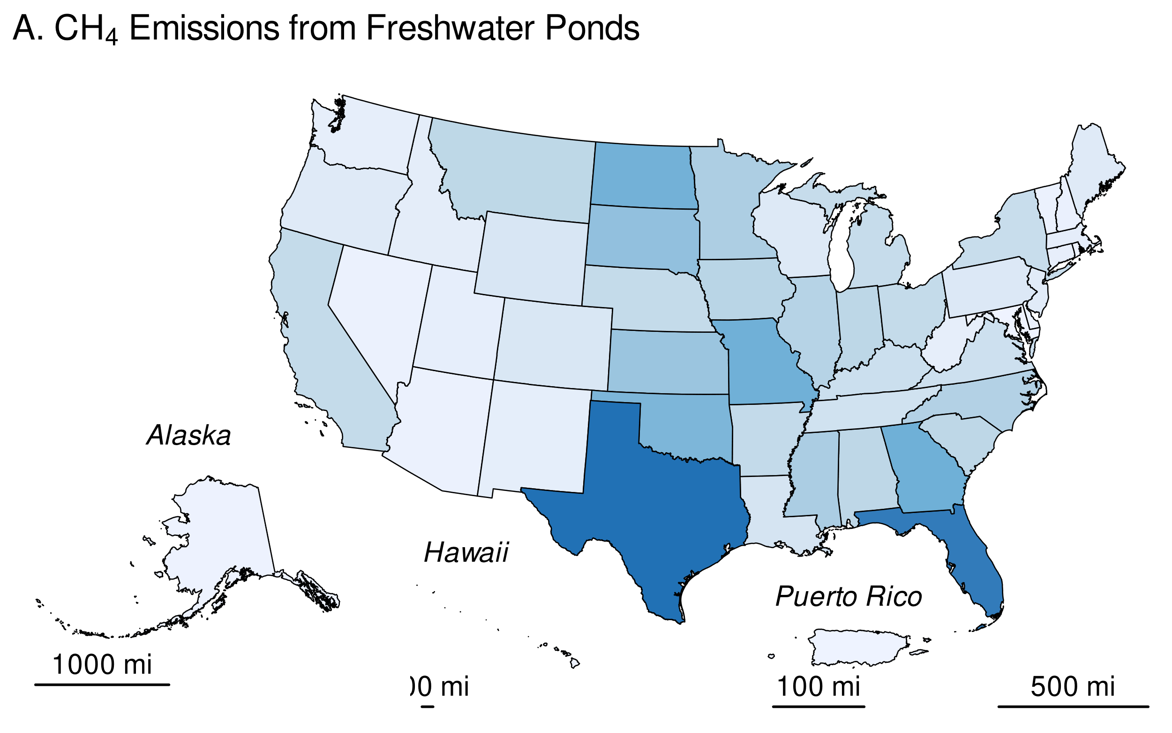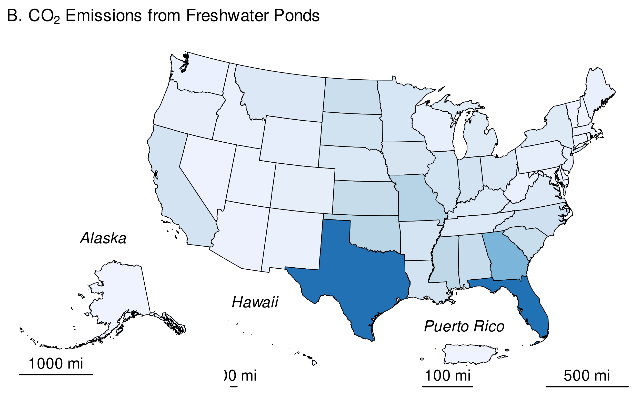

### Methodology and Time-Series Consistency

Estimates of CH4 and CO2 emissions for other constructed waterbodies in land converted to flooded land follow the Tier 1 methodology in IPCC (2019). All calculations are performed at the state level and summed to obtain national estimates. Greenhouse gas emissions from the surface of these flooded lands are calculated as the product of flooded land surface area and an emission factor (Table 6-115). Due to a lack of empirical data on CO2 emissions from recently created ponds, IPCC (2019) states “For all types of ponds created by damming, the methodology described above to estimate CO2 emissions from land converted to reservoirs may be used.” This *Inventory* uses IPCC default CO2 emission factors for land converted to reservoirs when estimating CO2 emissions from land converted to freshwater ponds. IPCC guidance also states that “there is insufficient information available to derive separate CH4 emission factors for recently constructed ponds…” and allows for the use of IPCC default CH4 emission factors for land remaining flooded land. Downstream emissions are not inventoried for other constructed waterbodies because 1) many of these systems are not associated with dams (e.g., excavated ponds and ditches), and 2) there are insufficient data to derive downstream emission factors for other constructed waterbodies that are associated with dams (IPCC 2019).

#### 

Table 29: Table 6-115: IPCC (2019) Default CH4 and CO2 Emission Factors for Other Constructed Waterbodies in Land Converted to Flooded Land

| Climate Zone | Surface emission factor (Mt CH<w:r><w:rPr><w:vertAlign w:val="subscript"></w:vertAlign></w:rPr><w:t xml:space="default">4</w:t></w:r> ha<w:r><w:rPr><w:vertAlign w:val="superscript"></w:vertAlign></w:rPr><w:t xml:space="default">-1</w:t></w:r> y<w:r><w:rPr><w:vertAlign w:val="superscript"></w:vertAlign></w:rPr><w:t xml:space="default">-1</w:t></w:r>) | Surface emission factor (Mt CO<w:r><w:rPr><w:vertAlign w:val="subscript"></w:vertAlign></w:rPr><w:t xml:space="default">2</w:t></w:r> ha<w:r><w:rPr><w:vertAlign w:val="superscript"></w:vertAlign></w:rPr><w:t xml:space="default">-1</w:t></w:r> y<w:r><w:rPr><w:vertAlign w:val="superscript"></w:vertAlign></w:rPr><w:t xml:space="default">-1</w:t></w:r>) |
| --- | --- | --- |
| Boreal | 0.1830 | 3.4467 |
| Cool Temperate | 0.1830 | 3.7400 |
| Warm Temperate Dry | 0.1830 | 6.2333 |
| Warm Temperate Moist | 0.1830 | 5.3533 |
| Tropical Dry/Montane | 0.1830 | 10.8167 |
| Tropical Moist/Wet | 0.1830 | 10.1567 |
| Note: downstream emissions are not estimated for freshwater ponds. | | |

#### Area Estimates

Other constructed waterbodies were identified from the NHDWaterbody layer in the National Hydrography Dataset Plus V2 (NHD),[21] the National Inventory of Dams (NID),[22] the National Wetlands Inventory (NWI),[23] and the Navigable Waterways (NW) network[24], and the EPA’s Safe Drinking Water Information System (SDWIS)[25]. The NHD only covers the conterminous United States, whereas the NID, NW and NWI also include Alaska, Hawaii, and Puerto Rico.

Waterbodies in the NHDWaterbody layer that were less than or equal to 20-years old, less than 8 ha in surface area, not identified as canal/ditch in NHD, and met any of the following criteria were considered freshwater ponds in land converted to flooded land: 1) the waterbody was classified “Reservoir” in the NHDWaterbody layer, 2) the waterbody name in the NHDWaterbody layer included “Reservoir”, 3) the waterbody in the NHDWaterbody layer was located in close proximity (up to 100 m) to a dam in the NID, 4) the NHDWaterbody GNIS name was similar to nearby NID feature (between 100 m to 1000 m).

EPA assumes that all features included in the NW are subject to water-level management to maintain minimum water depths required for navigation and are therefore managed flooded lands. NW features that were less than 8 ha in surface area and not identified as canals/ditch (see below) were considered freshwater ponds. Only 2.1 percent of NW features met these criteria, and they were primarily associated with larger navigable waterways, such as lock chambers on impounded rivers.

NWI features were considered “managed” if they had a special modifier value indicating the presence of management activities (Figure 6-19). To be included in the flooded lands inventory, the managed flooded land had to be wet or saturated for at least one season per year (see ‘Water Regime’ in Figure 6-19). NWI features that met these criteria, were less than 8 ha in surface area, and were not a canal/ditch were defined as freshwater ponds.

Any NWI or NHD feature that intersected a drinking water intake point from SDWIS was assumed to be “managed”. The rational being that a waterbody used as a source for public drinking water is typically managed in some capacity - by flow and/or volume control.

Surface areas for other constructed waterbodies were taken from NHD, NWI or the NW. If features from the NHD, NWI, or the NW datasets overlapped, duplicate areas were erased. The first step was to take the final NWI flooded lands features and use it to identify overlapping NHD features. If the NHD feature had its center in a NWI feature, it was removed from analysis. Next, remaining NHD features were erased from any remaining overlapping NWI features. Final selections of NHD and NWI features were used to erase any overlapping NW waterbodies.

The age of other constructed waterbody features was determined by assuming the waterbody was created the same year as a nearby (up to 100 m) NID feature. If no nearby NID feature was identified, it was assumed the waterbody was greater than 20-years old throughout the time series. No canal/ditch features were associated with a nearby dam, therefore all canal/ditch features were assumed to be greater than 20-years old through the time series.

For the year 2022, this *Inventory* contains 5.6439102^{5} ha of freshwater ponds in land converted to flooded land. The surface area of freshwater ponds decreased by -0.1018158 percent from 1990 to 2022 due to flooded lands aging out of land converted to flooded land more quickly than new flooded lands entered the category. The greatest reduction in freshwater pond surface area occurred in Iowa, Kansas, and Georgia (Table 6-117). Freshwater ponds in the 2021 *Inventory* are most abundant in Nebraska, Montana, and Kansas (Figure 6-22).

##### 

Table 30: Table 6-116: National Surface Area Totals of Other Constructed Waterbodies in Land Converted to Flooded Land (ha)

| Other Constructed Waterbodies | 1990 | 2005 | 2019 | 2020 | 2021 | 2022 | 2023 |
| --- | --- | --- | --- | --- | --- | --- | --- |
| Freshwater Pond | 628,369 | 628,841 | 628,341 | 628,106 | 596,043 | 564,391 | 532,862 |

##### 

**Figure 6-22: Surface Area of Other Constructed Waterbodies in Land Converted to Flooded Land (ha) in 2023**

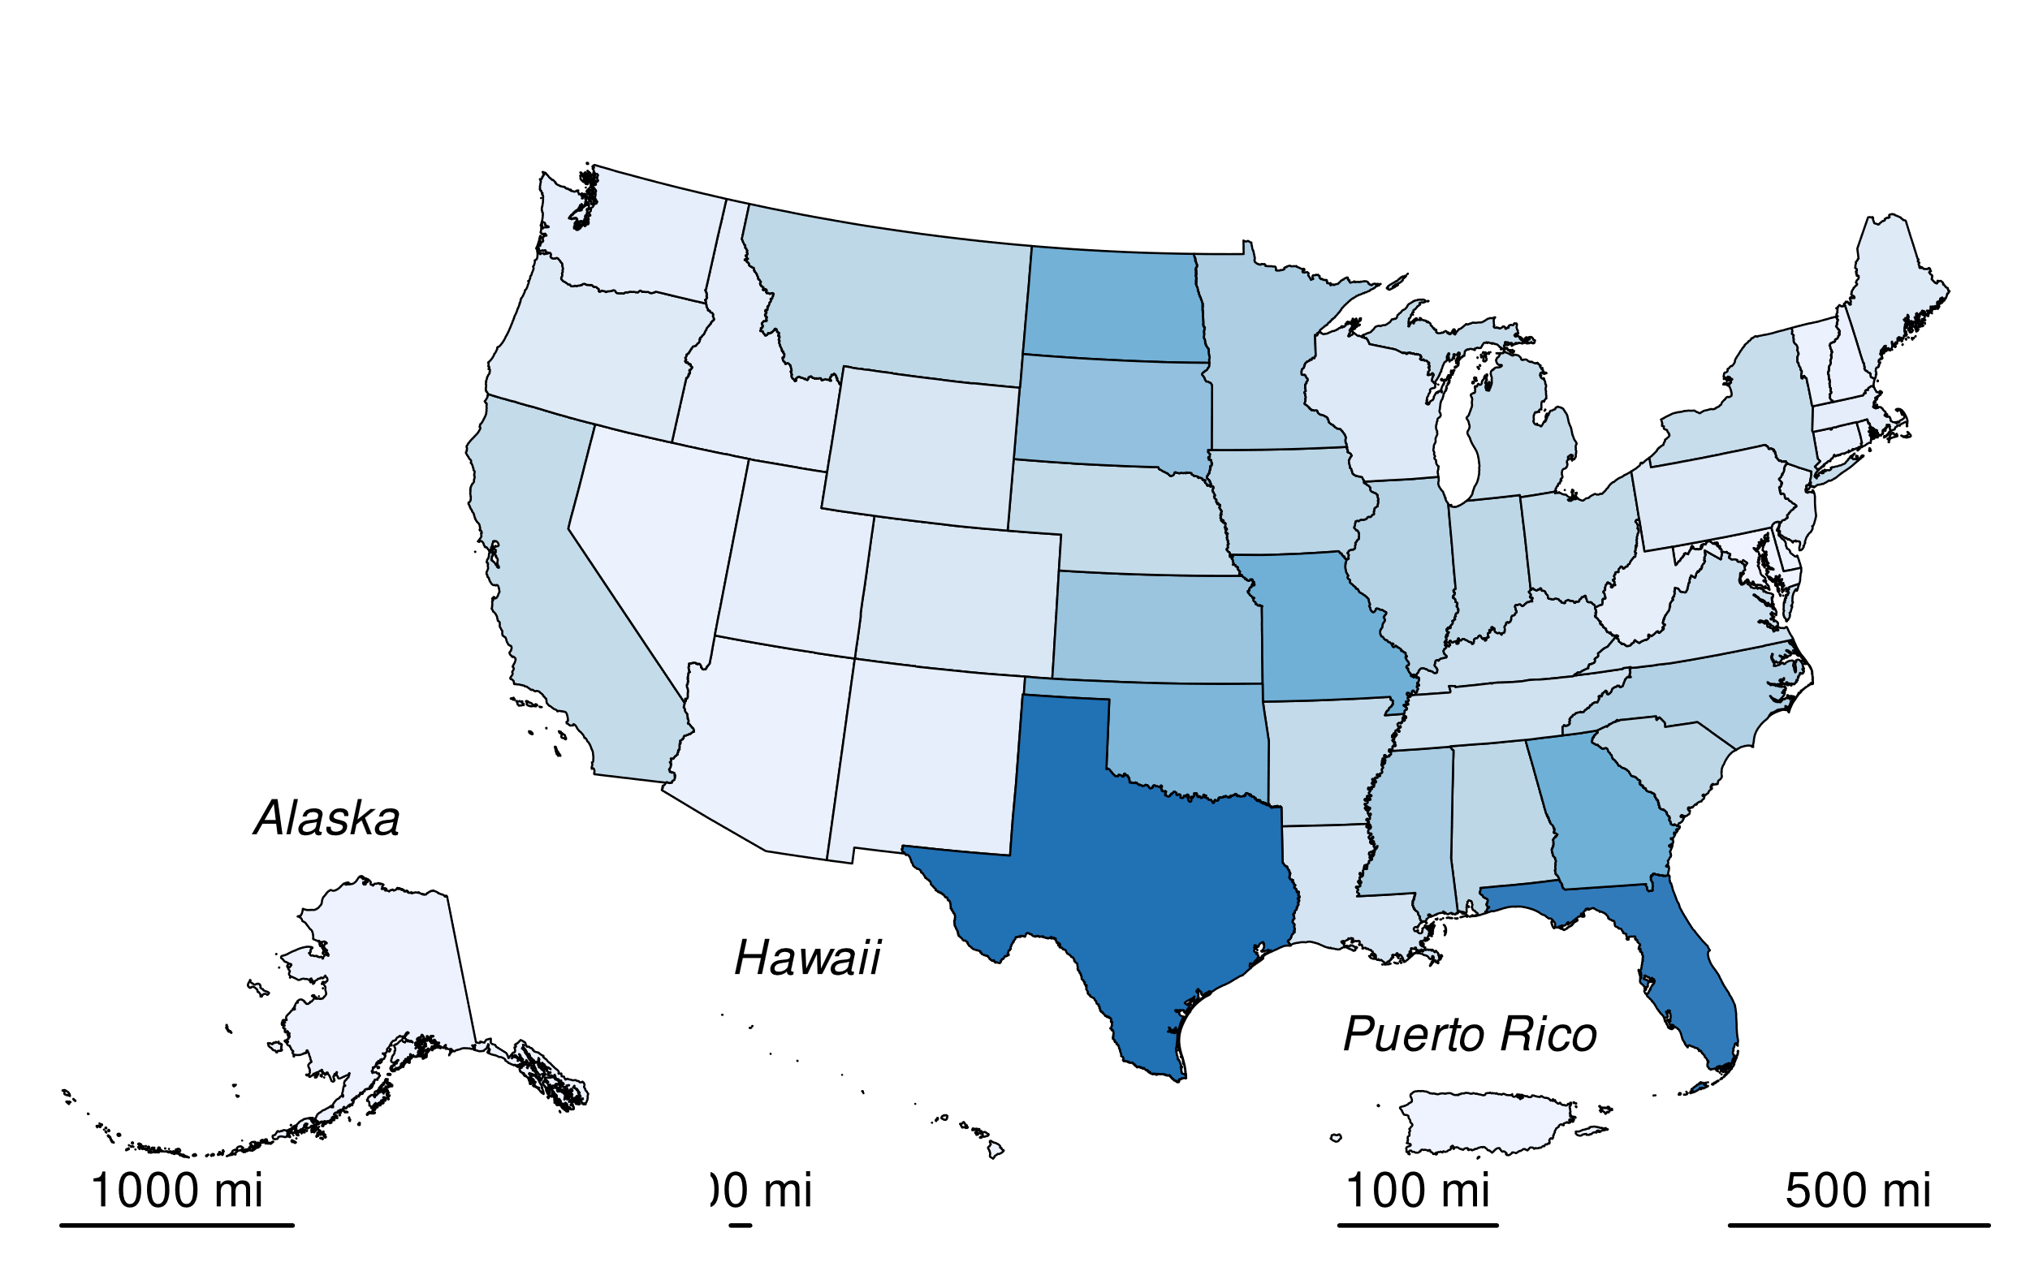

Table 31: Table 6-117: State Surface Area Totals of Other Constructed Waterbodies in Land Converted to Flooded Land (ha)

| State | 1990 | 2005 | 2019 | 2020 | 2021 | 2022 | 2023 |
| --- | --- | --- | --- | --- | --- | --- | --- |
| Alabama | 16,258 | 16,177 | 16,058 | 16,165 | 15,279 | 14,546 | 13,722 |
| Alaska | 688 | 679 | 633 | 638 | 595 | 565 | 541 |
| Arizona | 1,474 | 1,501 | 1,352 | 1,339 | 1,257 | 1,167 | 1,082 |
| Arkansas | 14,194 | 14,102 | 14,365 | 14,440 | 13,705 | 12,939 | 12,251 |
| California | 14,100 | 14,061 | 14,216 | 14,200 | 13,451 | 12,740 | 12,011 |
| Colorado | 7,373 | 7,564 | 7,331 | 7,310 | 6,935 | 6,501 | 6,133 |
| Connecticut | 2,709 | 2,719 | 2,681 | 2,666 | 2,560 | 2,418 | 2,283 |
| Delaware | 1,239 | 1,310 | 1,390 | 1,403 | 1,330 | 1,252 | 1,180 |
| District of Columbia | 2 | 2 | 8 | 8 | 8 | 8 | 8 |
| Florida | 46,784 | 47,088 | 46,786 | 46,802 | 44,379 | 41,973 | 39,577 |
| Georgia | 32,586 | 32,859 | 32,395 | 32,301 | 30,681 | 28,945 | 27,308 |
| Hawaii | 434 | 422 | 435 | 436 | 422 | 394 | 364 |
| Idaho | 3,702 | 3,590 | 3,746 | 3,745 | 3,593 | 3,382 | 3,203 |
| Illinois | 18,298 | 18,003 | 17,773 | 17,855 | 16,973 | 16,063 | 15,195 |
| Indiana | 16,203 | 16,370 | 16,372 | 16,355 | 15,591 | 14,790 | 13,967 |
| Iowa | 17,256 | 17,349 | 17,283 | 17,285 | 16,407 | 15,530 | 14,615 |
| Kansas | 23,687 | 23,553 | 23,838 | 23,744 | 22,530 | 21,350 | 20,181 |
| Kentucky | 11,838 | 11,818 | 11,853 | 11,866 | 11,264 | 10,665 | 10,009 |
| Louisiana | 8,732 | 8,947 | 8,787 | 8,757 | 8,277 | 7,792 | 7,385 |
| Maine | 5,477 | 5,330 | 5,333 | 5,335 | 5,105 | 4,834 | 4,589 |
| Maryland | 12 | 9 | 22 | 19 | 19 | 19 | 19 |
| Massachusetts | 3,480 | 3,473 | 3,463 | 3,456 | 3,273 | 3,072 | 2,893 |
| Michigan | 13,290 | 13,447 | 13,387 | 13,417 | 12,794 | 12,077 | 11,390 |
| Minnesota | 19,004 | 19,547 | 19,830 | 19,823 | 18,911 | 17,878 | 16,938 |
| Mississippi | 20,797 | 20,916 | 20,708 | 20,599 | 19,449 | 18,432 | 17,354 |
| Missouri | 31,986 | 31,770 | 31,874 | 31,898 | 30,184 | 28,706 | 27,140 |
| Montana | 16,252 | 16,100 | 16,052 | 16,122 | 15,288 | 14,458 | 13,683 |
| Nebraska | 14,105 | 13,911 | 14,210 | 14,166 | 13,430 | 12,770 | 12,044 |
| Nevada | 1,259 | 1,286 | 1,317 | 1,307 | 1,217 | 1,144 | 1,048 |
| New Hampshire | 1,580 | 1,536 | 1,605 | 1,619 | 1,552 | 1,478 | 1,427 |
| New Jersey | 4,612 | 4,566 | 4,425 | 4,452 | 4,191 | 3,981 | 3,790 |
| New Mexico | 3,197 | 3,250 | 3,125 | 3,127 | 2,980 | 2,825 | 2,680 |
| New York | 12,973 | 12,907 | 12,868 | 12,826 | 12,171 | 11,518 | 10,847 |
| North Carolina | 18,441 | 18,606 | 18,794 | 18,738 | 17,800 | 16,894 | 15,873 |
| North Dakota | 31,709 | 31,687 | 31,407 | 31,430 | 29,845 | 28,347 | 26,766 |
| Ohio | 14,537 | 14,330 | 14,080 | 14,037 | 13,293 | 12,617 | 11,920 |
| Oklahoma | 29,873 | 29,656 | 29,504 | 29,561 | 28,025 | 26,569 | 25,165 |
| Oregon | 5,459 | 5,656 | 5,347 | 5,302 | 4,963 | 4,710 | 4,431 |
| Pennsylvania | 6,113 | 6,116 | 6,283 | 6,271 | 5,937 | 5,628 | 5,352 |
| Puerto Rico | 175 | 194 | 225 | 215 | 203 | 186 | 179 |
| Rhode Island | 610 | 590 | 670 | 674 | 647 | 603 | 567 |
| South Carolina | 15,817 | 15,875 | 16,103 | 16,150 | 15,362 | 14,535 | 13,757 |
| South Dakota | 25,268 | 25,663 | 25,767 | 25,780 | 24,419 | 23,078 | 21,708 |
| Tennessee | 10,315 | 10,309 | 10,148 | 10,154 | 9,643 | 9,120 | 8,578 |
| Texas | 49,381 | 49,227 | 49,294 | 49,306 | 46,887 | 44,388 | 41,861 |
| Utah | 3,077 | 2,972 | 3,037 | 3,021 | 2,861 | 2,709 | 2,555 |
| Vermont | 1,231 | 1,195 | 1,263 | 1,264 | 1,196 | 1,113 | 1,049 |
| Virginia | 11,334 | 11,402 | 11,195 | 11,142 | 10,532 | 9,992 | 9,435 |
| Washington | 3,132 | 3,003 | 3,153 | 3,115 | 2,939 | 2,790 | 2,661 |
| West Virginia | 3,073 | 3,067 | 3,082 | 3,066 | 2,937 | 2,805 | 2,637 |
| Wisconsin | 5,901 | 5,861 | 6,016 | 6,018 | 5,704 | 5,390 | 5,127 |
| Wyoming | 7,343 | 7,272 | 7,453 | 7,385 | 7,051 | 6,709 | 6,382 |
| **Total** | **628,369** | **628,841** | **628,341** | **628,106** | **596,043** | **564,391** | **532,862** |
| Note: Totals may not sum to due independent rounding. | | | | | | | |

##### 

### Uncertainty

Uncertainty in estimates of CO2 and CH4 emissions from land converted to flooded land–other constructed water bodies include uncertainty in the default emission factors and the flooded land area inventory. Uncertainty in emission factors is provided in the *2019 Refinement to the 2006 IPCC Guidelines* (IPCC 2019). Uncertainties in the spatial data include 1) uncertainty in area estimates from the NHD and NW, and 2) uncertainty in the location of dams in the NID and drinking water intakes in SDWIS. Overall uncertainties in the NHD, NWI, NID, and NW are unknown, but uncertainty for remote sensing products is ±10 to 15 percent (IPCC 2003). EPA assumes an uncertainty of ± 15 percent for the flooded land area inventory based on expert judgment. These uncertainties do not include the underestimate of pond surface area discussed above.

#### 

### QA/QC and Verification

The National Hydrography Data (NHD) is managed by the USGS with collaboration from many other federal, state, and local entities. Extensive QA/QC procedures are incorporated into the curation of the NHD. The National Inventory of Dams (NID) is maintained by the U.S. Army Corps of Engineers (USACE) in collaboration with the Federal Emergency Management Agency (FEMA) and state regulatory offices. USACE resolves duplicative and conflicting data from 68 data sources, which helps obtain the more complete, accurate, and updated NID. The Navigable Waterways (NW) dataset is part of the U.S. Department of Transportation (USDOT)/Bureau of Transportation Statistics (BTS) National Transportation Atlas Database (NTAD). The NW is a comprehensive network database of the nation’s navigable waterways updated on a continuing basis. U.S. Fish and Wildlife Service is the principal agency in charge of wetland mapping including the National Wetlands Inventory. Quality and consistency of the Wetlands Layer is supported by federal wetlands mapping and classification standards, which were developed under the oversight of the Federal Geographic Data Committee (FGDC) with input by the FGDC Wetlands Subcommittee. This dataset is part of the FGDC Water-Inland Theme, which is co-chaired by the FWS and the U.S. Geological Survey. The EPA’s Safe Drinking Water Information System (SDWIS) tracks information on drinking water contamination levels as required by the 1974 Safe Drinking Water Act and its 1986 and 1996 amendments.

General QA/QC procedures were applied to activity data, documentation, and emission calculations consistent with the U.S. Inventory QA/QC plan, which is in accordance with Vol. 1 Chapter 6 of the *2006 IPCC Guidelines* (see Annex 8 for more details). All calculations were executed independently in Excel and R. Ten percent of state and national totals were randomly selected for comparison between the two approaches to ensure there were no computational errors.

### Recalculations Discussion

The EPA’s SDWIS is a new data source used in the current (1990 through 2022) *Inventory*. The assumption is that any waterbody used as a public drinking water source is managed in some capacity - by flow and/or volume control. This data source added 54 features totaling 173 ha of other constructed waterbodies.

The National Inventory of Dams (NID) data are updated regularly. The version of NID used for the current Inventory contains 47 new dams and updated values for “year of dam completion” for 975 dams relative to the previous (1990 through 2021) *Inventory* data. Similarly, the National Wetlands Inventory (NWI) is periodically updated. The NWI version used for the current Inventory has major updates for MS, ND, NM, and MT.

The net effect of these recalculations was an average annual increase in CH4 and CO2 emissions from other constructed waterbodies of 0.03 MMT CO2 Eq., or 51 percent, over the time series from 1990 to 2021 compared to the previous *Inventory*.

### Planned Improvements

Features < 8 ha in the NW that were not identified as canal/ditch were defined as freshwater ponds. Many of these features are lock chambers connected to an upstream reservoir. These systems likely have emission rates more similar to a reservoir than freshwater pond. In the next (i.e., 1990 through 2023) *Inventory* these systems will be classified as reservoirs.

# Uncertainty analysis–>

1. See <https://www.usgs.gov/core-science-systems/ngp/national-hydrography>.
2. See <https://nid.sec.usace.army.mil>.
3. See <https://www.fws.gov/program/national-wetlands-inventory/data-download>.
4. See <https://hifld-geoplatform.opendata.arcgis.com/maps/aaa3767c7d2b41f69e7528f99cf2fb76_0/about>.
5. See <https://www.epa.gov/enviro/sdwis-overview>. Not publicly available due to security concerns
6. See <https://www.census.gov/geographies/mapping-files/time-series/geo/carto-boundary-file.html>.
7. See <https://www.epa.gov/air-research/research-emissions-us-reservoirs>.
8. See <https://www.usgs.gov/core-science-systems/ngp/national-hydrography>.
9. See <https://nid.sec.usace.army.mil>.
10. See <https://hifld-geoplatform.opendata.arcgis.com/maps/aaa3767c7d2b41f69e7528f99cf2fb76_0/about>.
11. See <https://www.epa.gov/enviro/sdwis-overview>. Not publicly available due to security concerns.
12. CITATION NEEDED
13. See <https://www.usgs.gov/core-science-systems/ngp/national-hydrography>.
14. See <https://nid.sec.usace.army.mil>.
15. See <https://www.fws.gov/program/national-wetlands-inventory/data-download>.
16. See <https://hifld-geoplatform.opendata.arcgis.com/maps/aaa3767c7d2b41f69e7528f99cf2fb76_0/about>.
17. See <https://www.epa.gov/enviro/sdwis-overview>. Not publicly available due to security concerns.
18. See <https://www.census.gov/geographies/mapping-files/time-series/geo/carto-boundary-file.html>.
19. See <https://nid.sec.usace.army.mil>.
20. See <https://www.epa.gov/air-research/research-emissions-us-reservoirs>.
21. See <https://www.usgs.gov/core-science-systems/ngp/national-hydrography>.
22. See <https://nid.sec.usace.army.mil>.
23. See <https://www.fws.gov/program/national-wetlands-inventory/data-download>.
24. See <https://hifld-geoplatform.opendata.arcgis.com/maps/aaa3767c7d2b41f69e7528f99cf2fb76_0/about>.
25. See <https://www.epa.gov/enviro/sdwis-overview>. Not publicly available due to security concerns